# 1 - Analysis

### 1.1 Introduction:

My project will be an endless 2D sidescroller game. Games within the sidescroller genre typically consist of a character, whose goal is to reach the end of the level with the highest score, dodging obstacles and completing objectives along the way.

Examples such as “CANABALT” and “Flappy Bird” have endless, procedurally generated levels however there are also sidescrollers such as “Geometry Dash” and “Super Mario Run” that have levels that are uniquely designed.

My game will include a singular, endless, procedurally generated level. There will be obstacles (also procedurally generated) placed in positions where it will be possible for the player to clear them.

There will be a background layer which will periodically become available to the player, which will reward them with a score boost once they reach the end, this will serve as one of the game’s objectives.

I would like to expand on the functionality of existing solutions such as the ones previously mentioned by adding a mechanic which allows players to rewind time. The player will be able to rewind time up to a limit specified within the difficulty selection. Snapshots will be taken at a set interval, recording details such as: player positions, player velocity, platform positions and score. With the use of a stack, when the player hits the rewind button, the program will compare the current state of the game with the most recently added snapshot and use linear interpolation to smoothly return the player to the intended position.

I will carry out research such as questionnaires to gain an idea of what audience to target when producing my product and define a set of expectations to make sure my end result is of a high quality to the average user in the target audience.

### 1.2 Investigation:

#### CANABALT:

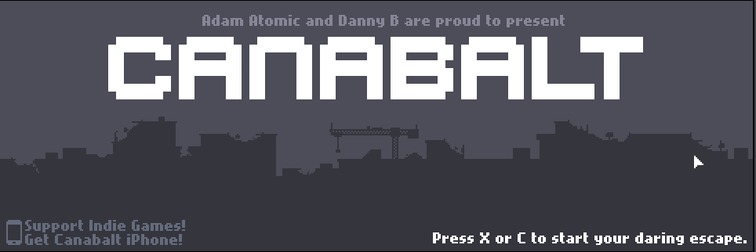

Canabalt is a 2D endless runner that features a single, procedurally (randomly) generated level. The game is compatible with PC as well as mobile devices (iOS, Android, PSP). The game first informs the user how to control the character on the main menu screen. The design of the screen is minimalistic and no settings can be altered from this screen. When the game is paused there is a small screen that displays further controls. This design choice is fitting as the whole game emphasises the idea of simplicity.

When the user presses one of the keys displayed on the main menu a new screen, containing the main game is loaded.

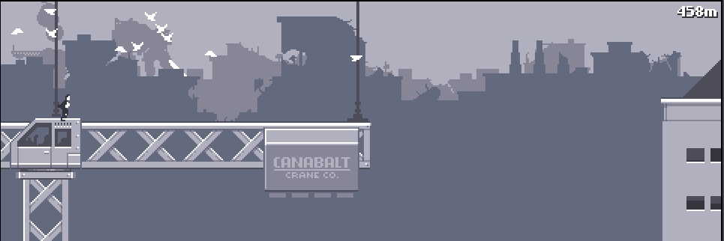

The sprite begins in an office building and continuously runs, gaining speed as the distance increases. Score is calculated and displayed in the top right of the screen, measured in meters. This is the only feature of the HUD and sticks with the simple theme. The user is limited to a single control of the sprite, which is making it jump. The game expands this simple concept by having the game increase in difficulty as the game goes on - distance between platforms increase, however they maintain their variety.

There are obstacles that are placed randomly on platforms which the player must jump over, if the player collides with one of these obstacles they will lose acceleration and the obstacle will fall off of the platform. These obstacles can throw off the player and make it much harder to time jumps at high speed.

It also features multiple layers/scenes in the game, each scrolling at different velocities. Although this is purely a graphical feature, it makes the game more interesting. Additional graphical features such as particles, flying birds, moving background objects etc.

I feel that there are many things I can take inspiration from in the gameplay of CANABALT. Since my game is also using a singular procedurally generated level, I can implement features similar to CANABALT to make sure that my game is exciting and appeals to the target audience of the genre.

**CANABALT - Main Menu / Pause Menu:**

|  |  |
| --- | --- |
| Things done well | Areas to improve |
| * Easy for the user to quickly start the game, knowing the basic controls. * Simple, so doesn’t overwhelm the user with advanced settings. * Features music and sound effects. | * Accessing settings like muting sounds is unintuitive as there is no clear option on the menu. * Difficulty settings could be included to make the game appeal to a wider audience. * It is not made clear if changing input binds is possible. |

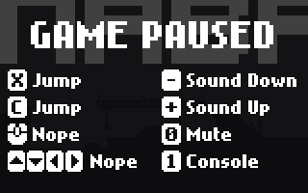

**CANABALT - Gameplay:**

|  |  |
| --- | --- |
| Strengths | Limitations |
| * Player movement is smooth. * Player can always jump across gaps. * Platforms have variety - different designs, some are collapsing. * Multiple layers make a parallax scrolling effect which adds depth, making the game more immersive. | * Leaderboard is only available on some platforms. * Objects only placed on the floor - lacks variety. * Player can only jump. * Layers could have some purpose other than graphics. |

#### Geometry Dash:

Geometry Dash is another game within the sidescroller, run and jump genre. It is however, made using handmade levels rather than procedurally generated ones. The objective of the game is to dodge the obstacles and collect coins placed along the map, as the player completes levels, more are unlocked. An essential part of the gameplay in Geometry Dash is the music, which is intended to allow the player to use their rhythm sense to aid them in timing their jumps as obstacles are placed in such a way that they match the rhythm of the song.

**Main menu:**

The main menu of Geometry Dash has 6 options allowing the user to view their statistics, their achievements, customize the appearance of their in-game sprite, create levels of their own and proceed to the song selection menu.

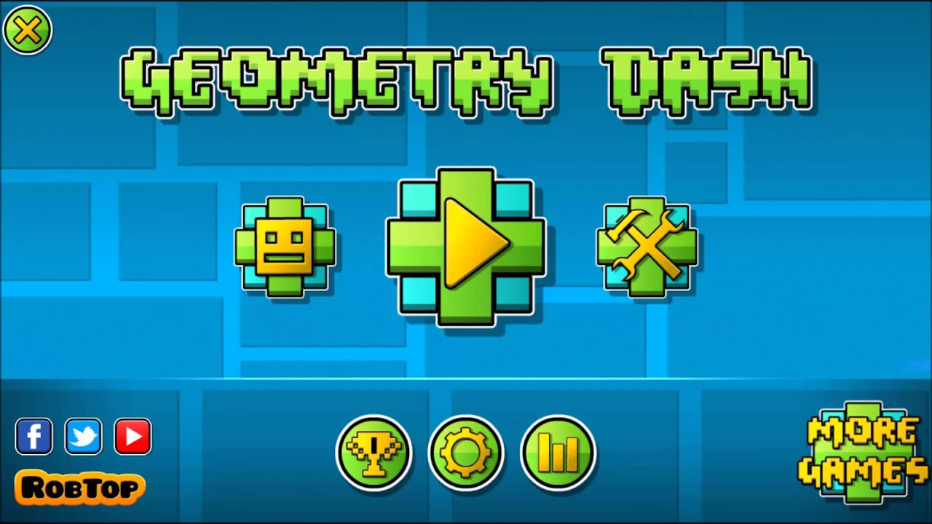

The fact that the game records the all-time statistics of the player and tracks achievements that they’ve made I feel is a good way of including a competitive feel to the game without a multiplayer mode. I believe it adds an ability to ‘beat’ or complete the game that wouldn’t be there otherwise. I would like my game to have this same aspect of competition, however I feel that due to the nature of my game (one endless level) it would be better implemented by tracking the player’s score and pushing them to beat other players scores, presented on a leaderboard. This way would work better with my game as it wouldn’t be possible to complete all achievements (if they were based on distance it would just continually increase). Instead, players can find competition in trying to be the best at the game.

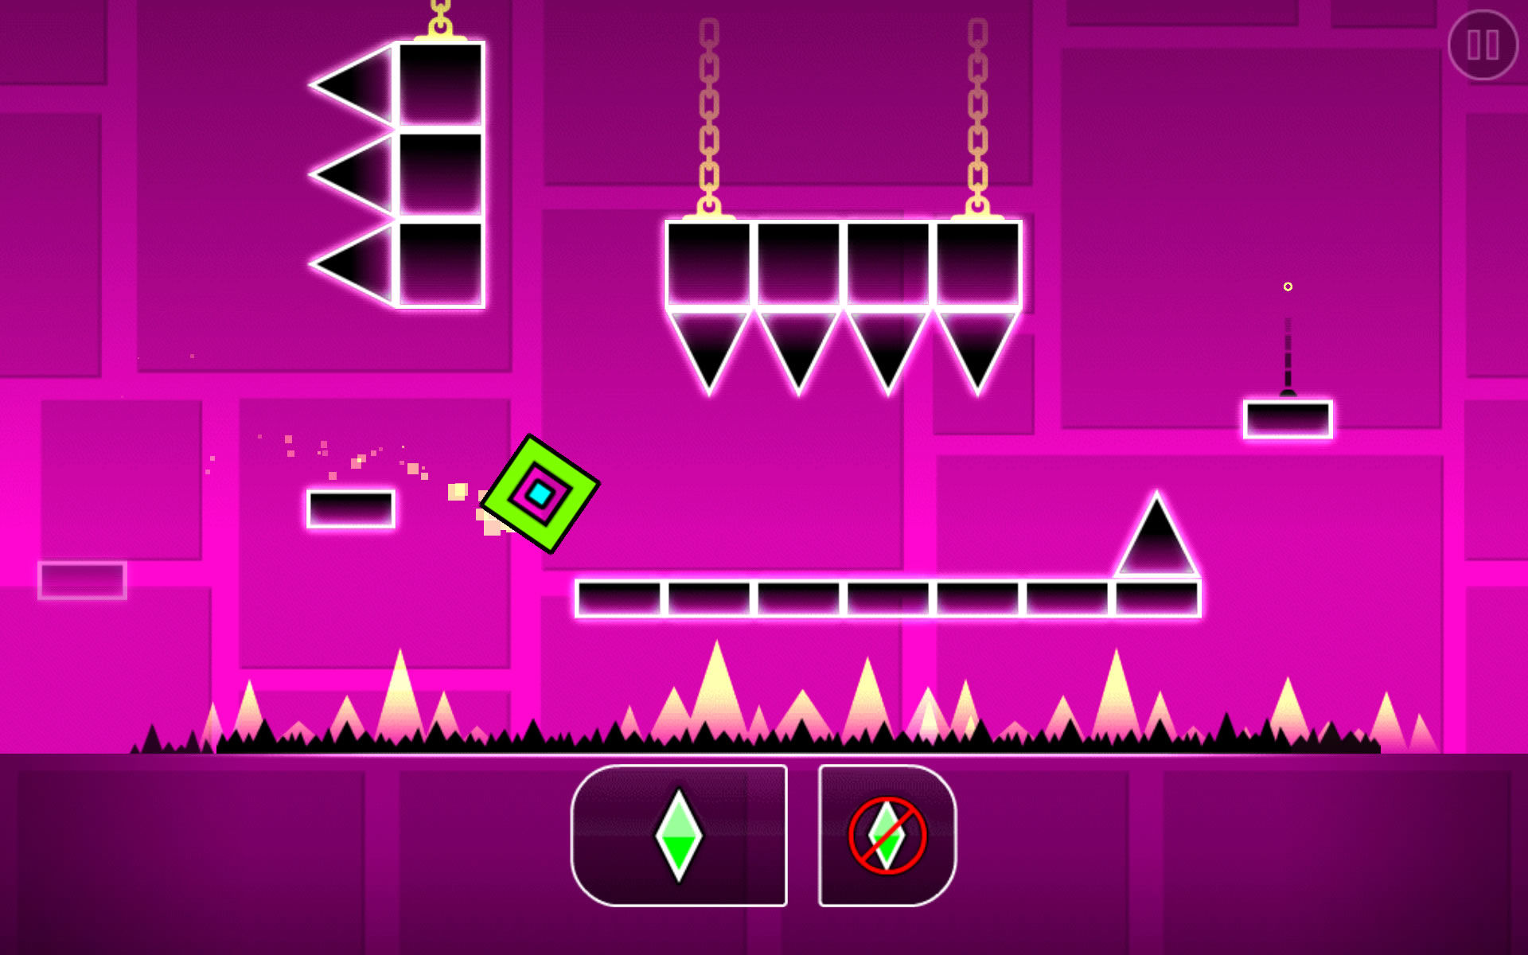

**Gameplay:**

In Geometry Dash the user can only control the y position of the sprite. In the main level if the user taps on the screen, the sprite will jump once or continuously if the screen was held.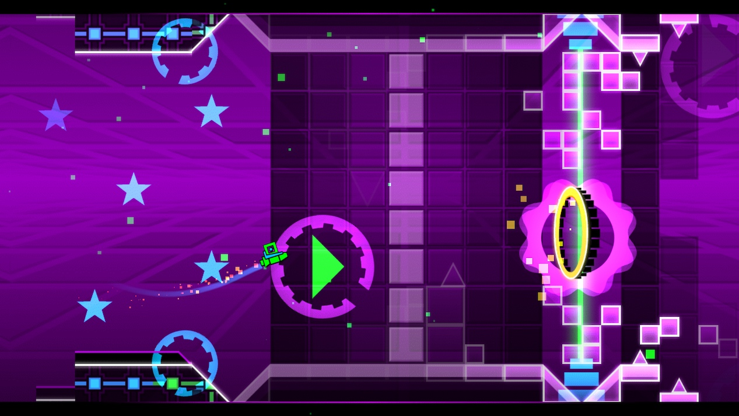

There are other parts within a level that are set out differently to the main part, this ‘mini level’ is accessed through a portal and it spawns the player back into the main level at the end.

The obstacles are mainly platforms and spikes, the placement of the platforms restrict the player’s options of movement to clear the obstacle, this makes the game quite challenging. To implement this type of placement in a procedurally generated level may be quite hard. However, the objective with my obstacles is to increase difficulty which could be measured based on the time window for error.

Similarly to CANABALT, Geometry Dash includes a background layer that scrolls at a slower speed than the foreground (parallax scrolling). It features other graphical effects such as a particle engine - a trail of particles is left behind the sprite and some are placed in the air. Another graphical implementation is transitions for when the platforms are drawn, which makes it appear smoother and increases the quality of the game.

It seems that parallax scrolling is a common graphical feature of games within this genre and I believe it adds depth and makes the game less boring to look at. Since it is so popular it is likely that the feature has good reception from the target audience, so I will try to implement parallax scrolling into my game to create a similar effect.

|  |  |
| --- | --- |
| Strengths | Limitations |
| * Unique idea to combine music with gameplay in this genre. * Visually appealing transitions and particle effects. * Variety with handmade levels * Comprehensive settings and customisation menus. * Allows the user to make their own levels. * Available on many platforms (PC, iOS, Android) | * Limit to how many levels the player can play. * Online leaderboard only available in some versions. * ‘Mini levels’ could have more variety. |

#### Braid:

Braid is another 2D platformer game however it is much different to the previous 2 games as it has more of a storyline and some different game mechanics. The game feels more like a traditional platformer game, but with the addition of interesting implementations including variations of time manipulation. The aim of the game is for the player to go through worlds and collect jigsaw pieces which reveal parts of the storyline. One of the worlds in Braid is called ‘Time and forgiveness’. Within this world the player is expected to make very precise movements to get to the jigsaw pieces which without the rewind aspect, would make the game almost unplayable.

**Gameplay:**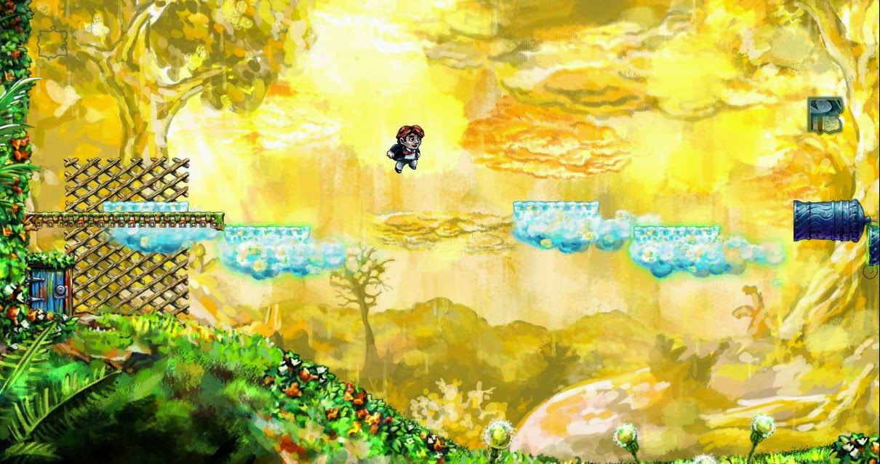

The user can control all directions of the sprite’s movement - up, down, left and right. The camera will centre on the player as they run to reveal more of the map however this depends on where they are. In certain rooms the camera does not follow the player, so they are able to freely explore every corner of the room.

A lot of the objectives rely on the player using the ‘enemy’ characters to reach certain areas. The player can jump on these ‘enemies’ and bounce to a higher position to get to the jigsaw pieces. There are also walls that the player can climb up allowing him to reach different parts of the map, another way the player can navigate the maps is by jumping across the moving platforms. The platforms are sometimes operated by levers and the player must use this in combination with other mechanics such as jumping on ‘enemies’ or rewinding time to access other parts of the map or reach a jigsaw piece. I believe this concept of combining the mechanics makes the game more challenging and engaging as the user must plan out how to complete an objective.

Braid also includes a lot of complex artwork and its design is more traditional compared to the other two games I have looked at. It does have parallax scrolling however it lacks things such as particles and transition effects. This is most likely since those design choices would be out of place for the art style of the game.

Looking into this game I have noticed the engagement that game mechanics like time manipulation provide. The use of time manipulation to make the game more playable and allow the user a ‘second chance’ appeals to me because my game will become very hard at high speeds. I feel that adding a mechanic such as rewinding time will make my game more enjoyable and reduce the difficulty to a more playable standard as the game goes on. However, since my game is not dependent on such a mechanic, the player will be restrained to a certain amount of ‘rewind time’ and they will not be able to use this after they have died.

|  |  |
| --- | --- |
| Strengths | Weaknesses |
| * Interesting mechanics (rewinding time). * Smooth movement of sprites. * Story is revealed as levels are completed which keeps the user engaged. * Available on multiple platforms * Complex mechanics create challenging gameplay. | * Lacks visual depth in comparison to other games in the genre. |

#### Questionnaire

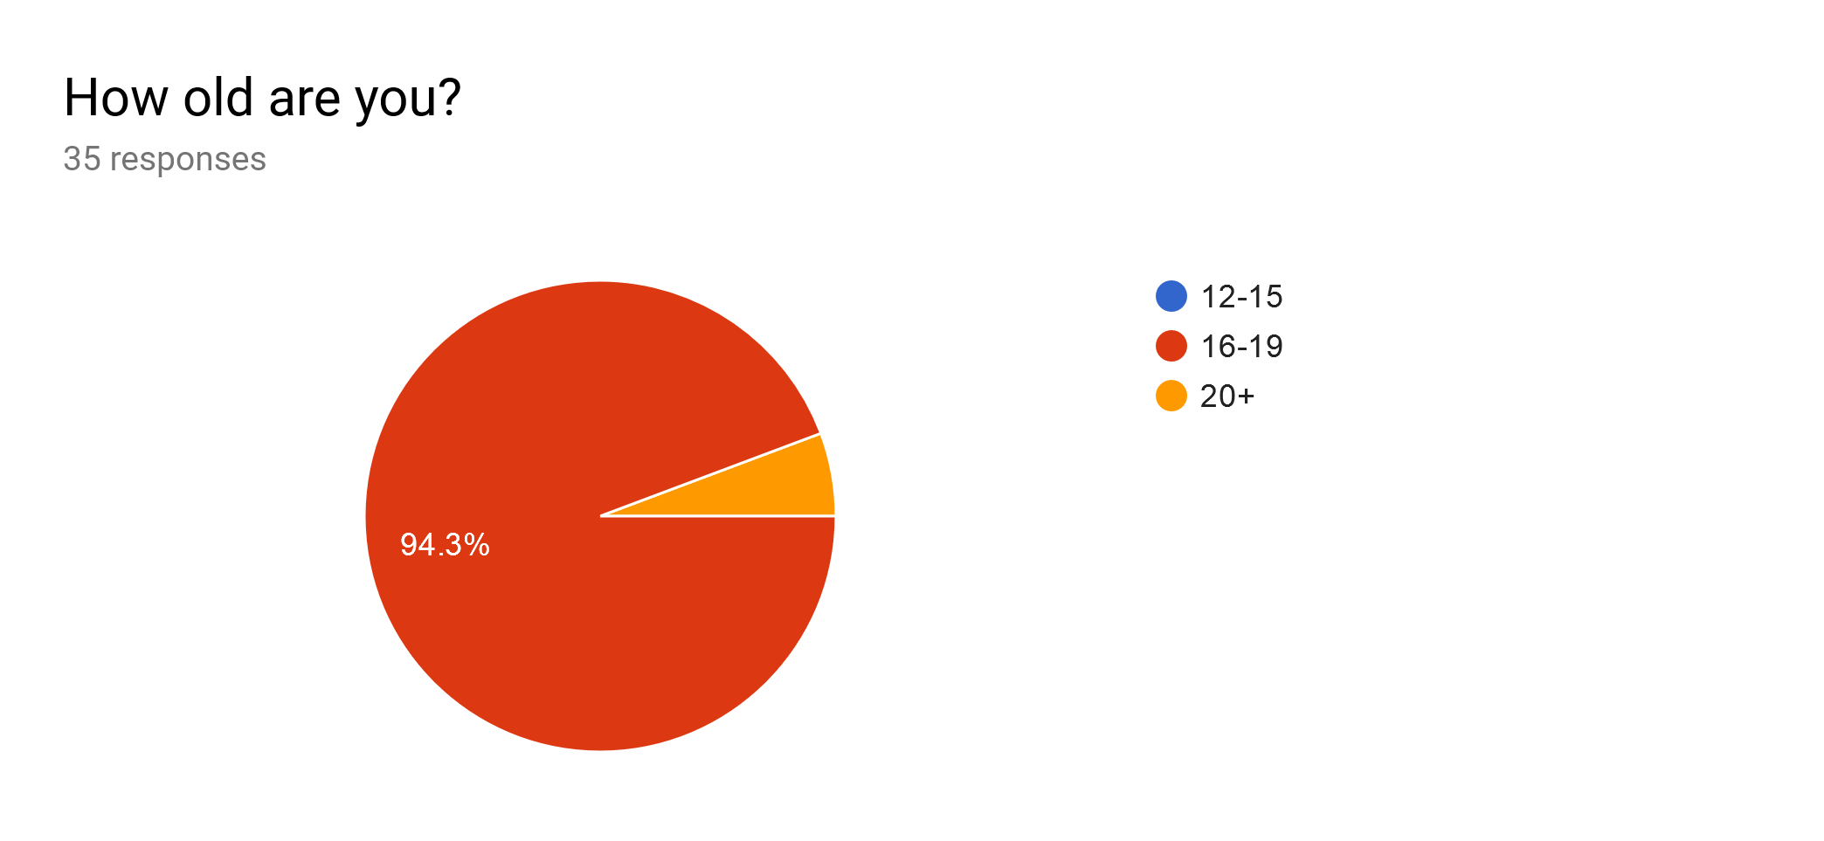

The vast majority of my audience will be people aged 16-19, this means that I shouldn’t need to include an intensive tutorial or instructions since people of this age are very experienced with games like mine. However, I will still include a brief instructions page so that anyone accessing the game can play.

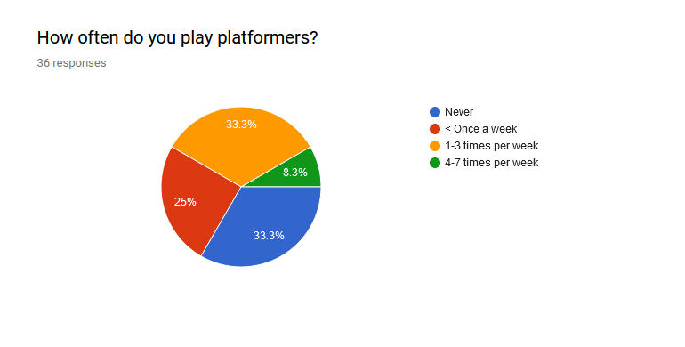

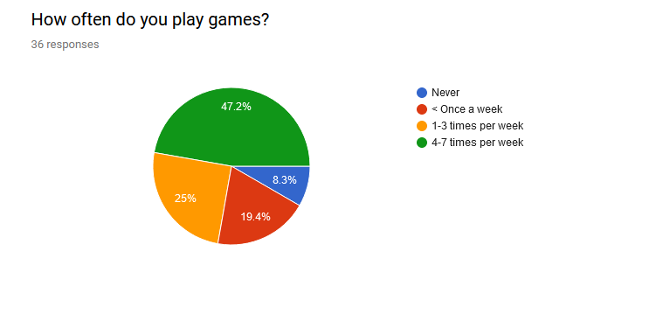

The most popular options for frequency of play (between people who play platformers) were ‘1-3 times per week’ and ‘less than once a week’, combined with the fact that the majority of people said they play games 4-7 times per week I can gather that most people don’t play games within the platformer genre as much as games from other genres. This means for the most part platform games serve as a ‘mini game’ to most people in my audience, I will try to have features in my game that will give it this feel.

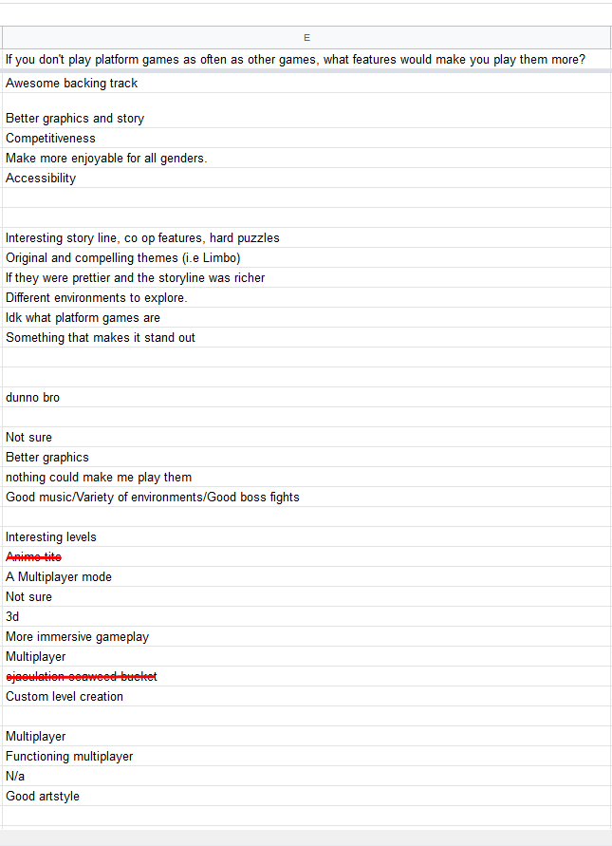 ‘Awesome backing track’, ‘Good music’ – I will invest some time in sound effects and background music if I have time as although it can add to the overall experience it doesn’t affect gameplay.

‘Better graphics’, ‘If they were prettier…’. – From my research I have gathered that one common graphical feature in well received platformers is parallax scrolling (where there are multiple layers of a game – each moving at different speeds), another is particle trails. I will at minimum try to implement these graphical features and if there is time, I will try to add other graphical features such as screen shaking on impact and weather such as wind and rain (will affect gameplay too).

‘Competitiveness’ – I will attempt to create competition in my game by including features like a leaderboard and tracking players’ highest scores.

Screen capture from a spreadsheet of responses to the questionnaire.

‘Accessibility’ – My game will be a browser application meaning that it will be very accessible since it will function on any device with a web browser, I will also amend the scaling on my application so it will work on the majority of devices (variety of screen sizes – mobile phones, desktops, laptops).

‘…co op features…’, ‘A multiplayer mode’, ‘Multiplayer’, ‘Functioning multiplayer’ – I will include a co-op multiplayer feature in my game where players can play together and combine their scores. There is a possibility that I will add a versus mode (last player alive wins) where players can connect online to play against friends (this is based on time restrictions), I believe multiplayer will also help achieve an important objective of mine which is to form a competitive aspect.

‘Variety of environments’ – I will consider adding scenes such as changes in weather and time of day e.g. night or day, windy or rainy (if I have time). This will serve as variety in environment as there will only be one endless level, so due to the nature of my game it will not be possible to have, for example, separate worlds based in different areas.

‘Good boss fights’ – This is not relevant to an endless runner, since the objective is to run the furthest distance, adding boss fights would serve no purpose and wouldn’t contribute to the gameplay. Boss fights are used to contribute to the storyline of a game as well as set goals for the player. My game will have no storyline, but I will try to create a feeling of a goal by implementing competition into my game.

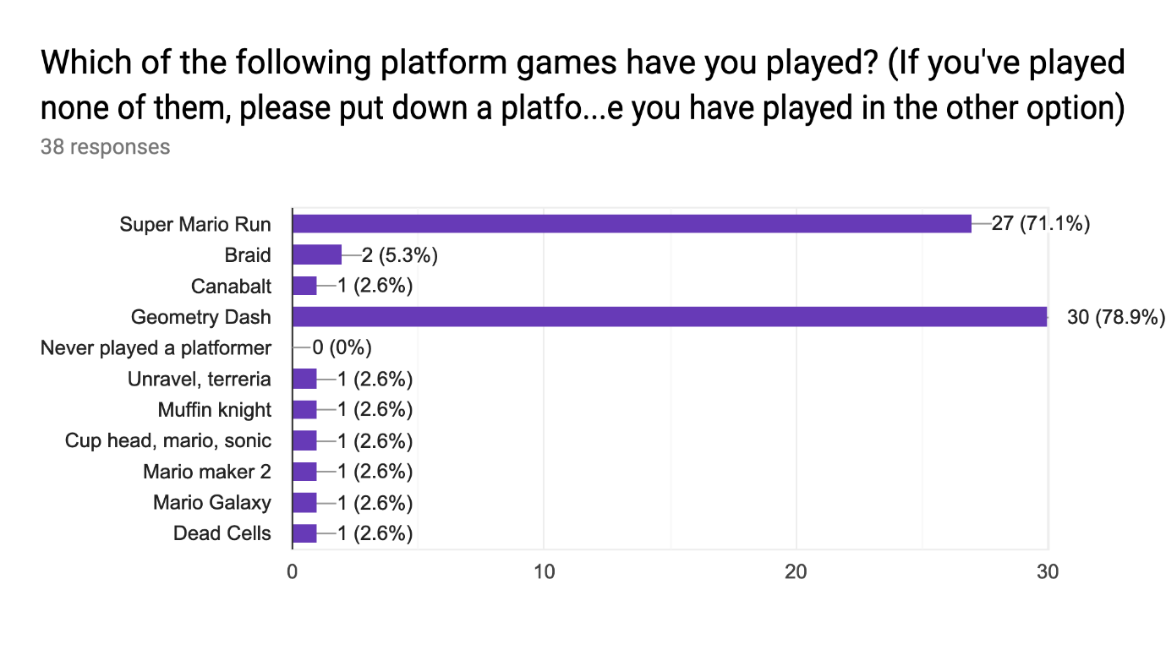

Super Mario Run and Geometry Dash are the most popular platform games within the audience, this suggests that these games were most successful in meeting the audience’s requirements. From the previous question it is clear that one important requirement of a platform game is the graphics (this was mentioned many times in responses). I will try to include (at minimum) graphical features found in these two games because the results suggest that graphics at this standard will be expected by the audience.

Super Mario Run also has a game mode called ‘Toad Rally’, this game mode is similar to a multiplayer mode. The player competes against a ghost character that represents the movement of another player’s run of the level (stored on the device locally – the movement is not streamed in real time).

The game determines who won depending on who collected the most coins and killed the most enemies. This could be implemented into my game based on how many obstacles were cleared the maximum distance achieved (if there is time, I could possibly implement other features such as coins which could be added as a win condition).

Since these are the favourite features of the users, I will comment on how I can reproduce features like these in my game:

‘The music’, ‘…/music’ – Music will be added if there is time as it is not essential to gameplay.

‘All I have to do is tap/press anywhere on the screen to play’ – My game will have an option to rebind the key of control however the default key will be set to space or a tap on a touchscreen.

‘The graphics’, ‘Artstyle…’ ‘the level design’

– The graphics in my game will have features similar to that of existing products.

‘Its quite difficult so makes you focus.’ ‘Difficulty of geometry dash’, ‘Difficulty’, ‘Easy game play’, ‘The pace’ ‘Easy to pick up and play…’, ‘it’s fast pace and how it tests your reaction speed’– the concept of my game will not be difficult at the starting speed, however at high speeds a high level of focus will be needed so the player can jump on time.

‘Simplicity’, ‘the simplicity’ – My game concept is simple as it the user is only controlling the timing of when the sprite jumps and there is only a single level.

‘The puzzles and co op features in unravel’ ‘The complex puzzle elements of Braid’ – It would be possible for me to implement co-op in my game. I will consider adding a co-op multiplayer mode where players can play in real time and their scores will be combined. Puzzles will not really work due to the nature of my game, there is no storyline so adding puzzles will seem to be out of place and there would need to be a theoretically endless amount of puzzle pieces on the level.

‘levelling up the character with points and from that the character getting noticeably better’ – Implementing this wouldn’t be suitable for my game because the character in my game would have no skills to get better. However, if there is time, I could implement a system where the character can buy benefits (e.g. starting with a half speed power-up, obstacle immunity power up) using a currency that is awarded at an interval of distance.

‘being able to jump to boxes to get powerups’, ‘the power-ups’ – My game will include power ups that will periodically appear on platforms or in mid-air.

‘Easy levelling system’ – There will be a leaderboard to represent player’s skill level rather than assigning a level group as this would encourage more competition and provide a concept of a goal rather than an endlessly increasing level.

‘The combat system’ – This is not relevant to my game as there is no combat.

‘Custom level creation’, ‘Custom levels’ ‘the different levels’, ‘the levels…’ – This is not relevant to my game since the levels are procedurally generated (uniquely generated by the computer). Assuming this suggestion is to provide variety, the endless level will be theoretically different each time so there will still be variety in my game.

Frequency of favourite features:

Clearly, out of the gameplay-based features, difficulty is the most favoured feature of each participant’s chosen platform games. Therefore, I will make it one of my main priorities to make this function of my game well-done and refined. Music is the most important extra feature so if there is time left to add more features, I will focus on music first.

From this question I attempted to find the features missing from current solutions so I could implement them into my game and provide an experience more suited to my audience.

Music – this is a very popular feature so I will add it if I have time.

‘Varied movement’ – The character will be able to slide under obstacles as well as jump over them.

‘For the whole game to be free’, “more levels I don’t have to pay for” – My game will be free.

‘More realistic features’ – Since my game is 2D and has a simplistic art style it won’t look realistic, but I can make the movement seem realistic by implementing physical features for example wind.

‘More options’ – the user will have the ability to change the difficulty of the game, change key bindings etc.

‘Community-made levels’ – won’t be implemented due to endless level design in my game.

‘Make it so u make a connection to the main character, like a plot’ – There will not be a storyline in my game so this will not be implemented.

‘For geo-dash the default level design is a bit boring and they all more or less look the same. For Mario run an alternative more challenging option would be nice because the default levels are a bit boring.’ - Since my game is procedurally generated no level will be exactly the same. The increasing speed within my game should make it challenging.

“Better detailed assets” – My game will have vector-based graphics design for the most part so it will be highly detailed.

“A multiplayer feature”, “Multiplayer”, “multiplayer or advanced AI to increase difficulty”– I will implement a multiplayer feature in my game (previously described). It is unlikely that I will implement an advanced AI as there will not be time, if there is time left I may implement a simple rule based AI that the player could compete against.

“Graphics” – I will have graphical features similar to other products.

“variety of gamemodes” – There will be at least 2 modes: Solo and multiplayer, if there is time, I will implement a co-op multiplayer mode too.

“More customisation”, “Ability to change the pace (easy, medium, hard) for each level” - The player will be able to customise the difficulty of the game – e.g how often obstacles are placed and how quickly the speed will increase. If there is time, I can add cosmetic features such as skins, colours of the sprite and theme of the game UI.

“Have a wider variety of traps”, “more obstacles” – There will at least be platforms acting as obstacles for the player to dodge, there will also be spikes on the floor (At minimum). If there is time, I will implement different types of traps.

“User modding” – since the levels are generated by the computer, there would not be much modding to be done, so there is not much reason to implement this.

“Make it more challenging” – the fact that my game is endless and includes increasing difficulty means that it can become very challenging.

“Additional items” – If there is time, I may add a store where players can use currency they have made from playing the game to buy starting power ups etc.

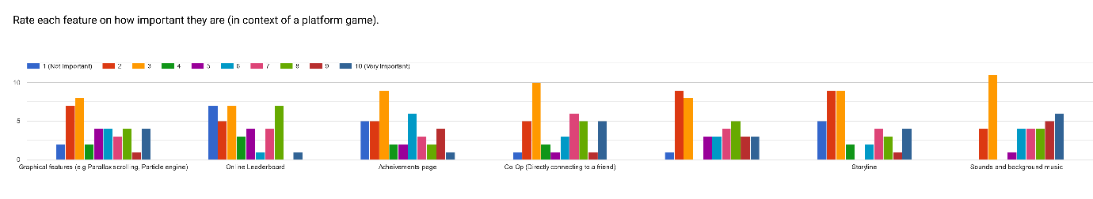

Missing label should say Co-Op multiplayer (Matchmaking)

Co-Op and Sounds/Background music had the most votes for very important out of all of the other options. This tells me, along with data from all of the other questions, that music is expected in a platformer game. However, music and sounds also had the most votes overall for 3/10 importance. This shows that although it is a good addition, players would not be bothered much if it wasn’t included.

If I have time I will put music in my game as it is clearly an expectation of the audience. Multiplayer is also highly requested which is reflected in this comparison of importance. Online leaderboard had the most votes in the top region of any other option suggesting that competition is very important in a platformer and users will want to be able to see how they compare against others. From this I can establish that I should invest a fair amount of my time into creating a functional leaderboard. At the same time, the online leaderboard had the most votes for least important so if I do spend time on it, it will only be after all my main features have been made functional (it will be one of the extra features).

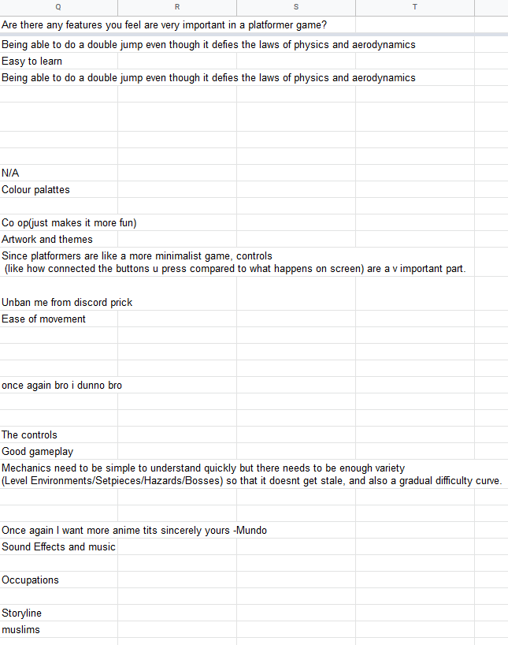I asked this question to find out if there are any specific features that the audience would like to see in a game within this genre. I will comment on the possibility of implementing each feature.

“Being able to do a double jump….” – I could implement this however it wouldn’t serve much purpose other than giving the player “safety net” if they mistime their jump but this is already provided by the rewind feature so I will only implement this if I have time at the end.



“Easy to learn” – There will be a help page at the main menu which will give a brief overview of controls and how the game works.



“Colour palattes”, “Artwork and themes” – The colour palate will



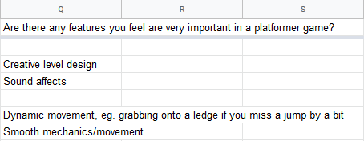be similar to other games in the genre, themes may be implemented if I have time as they aren’t essential to gameplay (high contrast colours, simple designs in general).

“Co op” – I will implement a multiplayer mode.

“controls…”, “The controls” – I will allow the player to control the key bindings but they will have defaults.

“Ease of movement” – the sprite will automatically run and the player will only control a jump with a single input which is fairly easy.

“Good gameplay” – Most of my time will be focussed on refining my gameplay to meet the standards of existing products, while also implementing new features that I feel will make the gameplay more interesting. (this is one of my main objectives)

“Mechanics….simple to understand...but enough variety…also a gradual difficulty curve” – The mechanics of my game are simple since the player will only control duck and jump of the sprite.

There will be a gradual difficulty curve as the game will become harder as time goes on. Variety will come from the “randomness” within obstacle placement and gaps within the platforms.

“Storyline” – my game will not have a storyline as there will only be one level.

“creative level design” – Since my levels are procedurally generated it would be hard to add a creative element, I will try to focus on creativity within the graphics elements and my main gameplay focus will be to make the levels challenging and playable.

“Sound affects” – If there is time, I will implement sound effects and music.

“Dynamic movement, e.g grabbing onto a ledge if you miss a jump by a bit” – I will implement this if I have time because it is a small feature and not essential to gameplay.

“smooth mechanics/movement” – I will attempt to make movements as smooth as possible.

#### Prototype

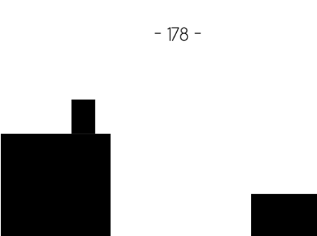To familiarise myself with the fundamental concepts of the game I will be designing, I produced a prototype. The player object is used purely approximate the bounds of the sprite. In the final solution, the player object will not be drawn to the screen but will be replaced by a sprite, the rectangular object will be very close in size and shape to the actual sprite, so it is fair to say anything colliding with the rectangle will be also colliding with the sprite. This approximation is much less time consuming as without it I would need to match the sprite exactly or use multiple shapes to make it more accurate, this level of accuracy would be negligible to the user.

My main focus with the prototype was to figure out how to create a basic, playable procedurally generated level. To create the platforms I set a maximum height and minimum height for each platform object, assigning a random value between these two heights. This way all platforms will have variety. For the sake of the prototype the gap between each platform is the same. In the finished solution there will be varied gaps also.

JavaScript is an object orientated language which is helpful for my game since I am able to assign properties to specific entities of it. OOP makes it easy to compare positions of for example the player and a platform to check for a collision.

The player class within my game holds the starting position of the player , the width, height and velocity etc. It has 2 main methods: draw and update. The draw method takes the starting x and y values of the player and draws it to the canvas (this is only an approximation of the player sprite and is drawn to make it easier to visualise how to program works, in the finished game it won’t be drawn to the screen – only the sprite will). The update function causes the player to fall if they’re not on a platform and checks whether there is a collision between the player and a platform, so they don’t fall through the surface etc. It also manages the increase in velocity when a player presses the jump button and the decrease in velocity when a player is in a position to fall by gravity (e.g not in collision with an object).

The platform class holds the position, width, height, velocity and a boolean value that tracks whether the platform has been instantiated yet – this is used so that during object detection the player’s position is only compared with on-screen objects. The main methods of this class are the move and the draw method. The draw method just draws the platform at the specified position and the move function decreases the x value of the platform resulting in it moving to the left. The velocity is multiplied by the “gamespeed” variable which will increase throughout the game.

Currently in the prototype there is no increasing speed, this will be added later but for the sake of simplicity I decided to work with the same speed throughout to get the fundamentals working.

Before the entering the game loop an array “surfacearray” is filled with platform objects, the main loop executes the move command on each item in this array. It also increments and draws the players score every frame (this frequency will change by the final product).

There are two main functions that aren’t part of any classes: “forcepos” (subroutine) and “detectCollision”. “forcepos” takes two parameters, those being the two objects to force out of each other’s boundaries. The function is used to force the player to stay on top of the platforms and stop the player from falling into the sides of a platform if they miss a jump. This is done by comparing the x and y positions of each object passed in and the condition of whether to force the player above the platform or to the side is decided by whether the sprite is positioned above within a gap or not.

“detectCollision” also takes two parameters and returns a Boolean value. It takes the two objects to check for a collision between. In the prototype this function is only used to check collisions between a platform and the player. This is done by checking if either of the conditions are true: player’s minimum y position is less than the platform’s maximum y position (player is above platform), player’s max x position is smaller than the platform’s min x position (player hasn’t reached platform yet), player’s min x position Is bigger than the platforms max x position (player is past platform).

Since this is evaluated using or operators if either one of these is true the function will return false and if neither are true it will return true. This could be done using and operators where all of the conditions for the objects to be in collision would need to be true however this would mean that many conditions would need to be true at minimum whereas with the current implementation only one condition will need to be true in many circumstances, this increases the efficiency of the function.

A video of the prototype: https://www.youtube.com/watch?v=66ErzLE6100&feature=youtu.be

#### Hardware Usage

I loaded the game in Google Chrome to test the amount of memory the game is using. The screenshot below shows the amount of memory used by Chrome with about:blank open (blank page).

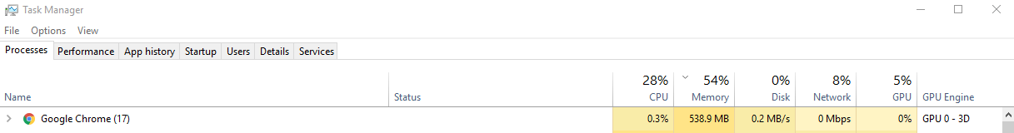

Here is the memory usage with only my game open in Chrome, it only uses about 160MB of memory which is very small since it is likely that the average consumer would have from 4 to 8GB of RAM. The CPU usage is also low at 12% however I have not tested this on other devices and the only CPU it has been tested on is a i5-7600K.



### 1.3 Constraints

My game should be accessible on desktop at minimum, since it is web based any device that has internet access and a web browser should be able to play. To make this possible I need to have reasonably fulfillable hardware requirements.

For PC:

* It is likely that 1GB of RAM will be sufficient for the game and most computers have at least 4GB of memory nowadays, so 1GB should be reasonable to ask for and will be good enough for the fully featured game, 1GB of memory is also a requirement for games such as CANABALT and Geometry Dash, and since my game is a similar product to this I feel I should aim to have performance at the same level.
* For the CPU, I have considered other Desktop platformers for example CANABALT, where the minimum requirement is an Intel Core 2 Duo U7600. This CPU would be able to run my game and the fact that similar existing products have used this as a minimum requirement, suggests that it would be a good base. During testing I will test my game on older computers and see how the game runs, and if I need to change any requirements.

For Mobile:

* 1GB of ram is expected for games like Geometry Dash and Super Mario Run, I will stick with this requirement as it works with similar products and the game will be unlikely to need more.
* Phones equivalent to the iPhone 5s and Samsung. Phones equivalent to the iPhone 5s and Samsung Galaxy S2 are able to run similar products such as Super Mario Run, with the specs of these phones my game should run fine on mobile.

I will test my game on multiple devices and screen sizes, I will also test it on older and newer devices, this will help me ensure that my game is compatible with these devices and if my minimum requirements are realistic.

### Data Flow and Diagrams

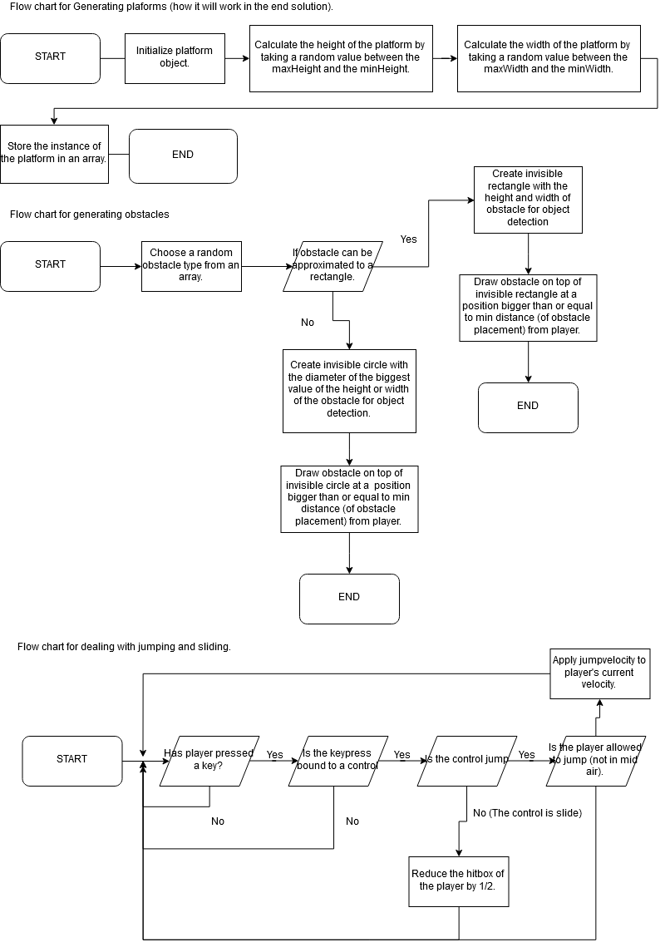Flowcharts:

Class Diagrams:

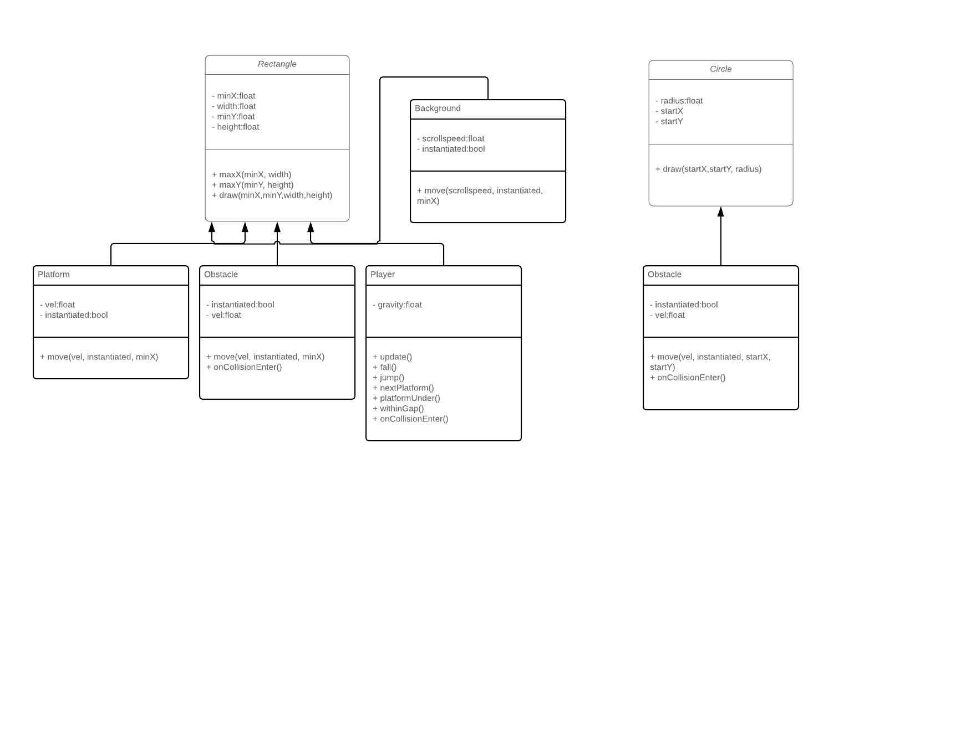

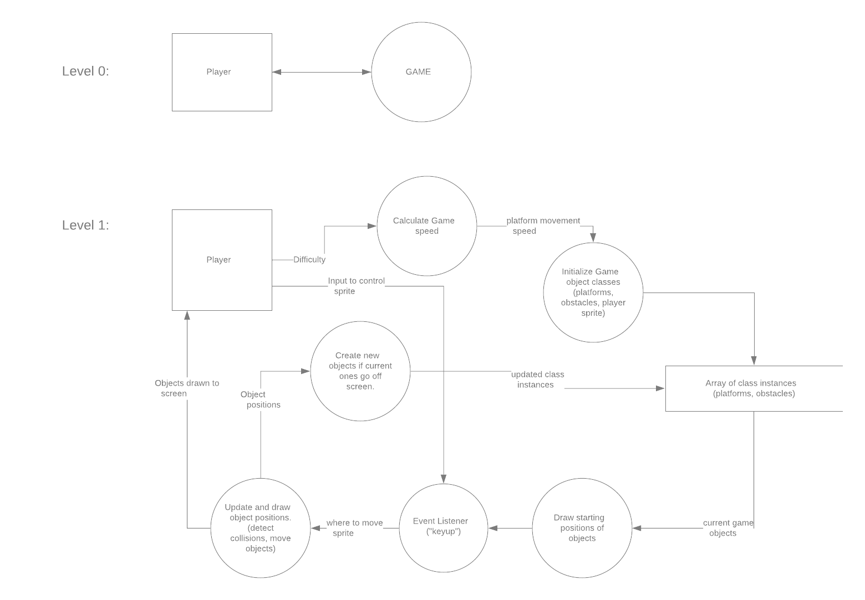Data Flow diagram:

### 1.4 Limitations

#### Programming Language Limitations

I intend to make my game web based so I will use JavaScript to code the functionality of the game.

However, some HTML and CSS will need to be used to create the fundamentals of the website. I feel

that this is the most suitable because I understand JavaScript and have experience with OOP and I

know most of the syntax required to create functions that would be needed for the project.

Alternatively, I could use Unity game engine and create my game as an application, but I feel that

this will reduce the complexity of my code greatly as many of the functions required for the game

mechanics will be provided by Unity. In addition, to use Unity I would need a thorough

understanding of C# which I am not as confident in which means that the project may take a lot

longer due to the extra time needed to get familiar with the syntax.

Another method is to use Python and Flask to make the web-based application. Python is the

language I am most familiar with However since I already have some knowledge of JavaScript, I feel

that it would be easier to use that instead of having to learn how to use Flask and go through that

intermediate step.

Using JavaScript means that my game has to be web based and this requires an extra step of having the file hosted online. An issue with this is that it requires more time to research and learn how to do it. However, a positive of this is that the site can be accessible across a wide range of devices without needing to use multiple coding languages.

### 1.5 - Objectives:

Must have objectives:

Main menu:

1. Buttons indicating a play, exit and settings option.
2. Settings menu must allow user to change binding of keys and other options such as volume (if I implement sound).
3. Must have a help page telling users briefly how to play (controls).

Gameplay:

1. Obstacles must have different types and be placed in a way that makes the game difficult but possible.
   1. Types such as spikes, platforms, wrecking ball (examples).
   2. Must be placed with small time window for error.
   3. Must be placed within a minimum and maximum distance from player to ensure it is possible to pass the obstacle.
   4. Some obstacles must slow the player’s acceleration
2. Platforms must be procedurally generated.
   1. Must have different surface types.
      1. Each surface type must have a different friction.
   2. Must have random value for the height and width (between a minimum and maximum).
   3. Must move automatically.
      1. Speed of movement must increase as the game time increases.
3. Must have “Game Over” screen.
   1. Shown when player dies by either hitting certain obstacles or falling out of bounds.
4. Player must be able to dodge obstacles:
   1. Must be able to slide and jump over objects.
   2. Must only be able to jump from a platform.
      1. Only a single jump.
5. Player must be able to rewind time.
   1. Must be able to go back in time by holding a key.
      1. Time the key is held for should be measured which will determine the amount of time to rewind.
   2. Amount of rewind time the player has must be shown on screen (represented as a bar).
      1. Once the player uses rewind the bar should drain.
      2. Bar should refill as the player continues to move through the level.
6. Player should be able to see score on game screen.
   1. Score should represent distance.

Graphics:

1. Must have multiple layers.
   1. Layers must scroll at different speeds (parallax scrolling).
2. Must support different screen sizes.
   1. At least standard mobile aspect ratios and 16:9 monitors for desktop/laptops.

Should have objectives

Main menu:

1. User should be able to select a difficulty.
2. User should be able to reset options.
   1. Key bindings should have a reset option.
   2. Sound levels should have a reset option.

Gameplay:

1. Should have multiple interactive layers.
   1. Should be at least 2 layers with different movement speed and intervals of object placement compared to main layer.
   2. Should have reduced/increased difficulty to main layer.
2. Player should be able to see their previous scores.
   1. Scores should be stored in either a csv or other data store (e.g database if I implement one).
   2. Player should be notified if they achieve a goal.
      1. Goals such as: Personal best, top 10 ranking (if I implement an online leaderboard).
3. Should have in game items.
   1. Coins that can be collected by the player.
   2. Power ups that can be collected.
      1. Power ups should affect the game.
         1. Power ups include: ½ speed, immunity to obstacles, platform distance reduction, rewind fill.
   3. Power ups should be placed in obtainable locations
      1. On top of platforms, in the jump path of platforms.

Graphics and extras:

1. Should have different scenes.
   1. At least 2 scenes for example night and day.
2. Should have **some** sound effects.
   1. Should have sound effects for starting the game, hitting an object/obstacle, starting a jump.

Could have objectives (If there is time)

Main menu:

1. Could have an online leaderboard.
   1. Leaderboard could sort highest scores of players and assign each player a worldwide rank based on the location of their highest score on the leaderboard.
   2. Whole leaderboard viewable from main menu.
   3. Could be implemented using a database.

Gameplay:

1. Co-op mode.
   1. Similar to the solo game mode however players’ score could be combined.
   2. Separate online leaderboard.
   3. Using rewind could affect both players.
   4. Power ups could affect both players.
   5. Dead players could be revived if their teammate survives a certain amount of time.
   6. Teammate could appear as a ghost on other players screen.
   7. Table showing each player’s contribution to the final score could be shown at the end.
2. Customisation of sprites and overall game UI.
   1. Customisation of the sprites/UI colour and look could be customised.
      1. A shop would be implemented where the player could buy these customisation items with an in game currency. (earned from playing).
3. Some layers could give score boosts.
   1. There could be layers that are accessible within a certain time period.
      1. Would be more challenging than the main layer (faster movement speed, more obstacles).
      2. Would provide a score boost at the end of the layer.

Graphics and extras:

1. Particles.
   1. A particle engine could be implemented which leaves trails behind players and generates some in mid air or for example the sky.
2. Weather such as rain and wind could be implemented.
3. Illusion of a camera.
   * 1. Screen could appear to follow player.
     2. Camera could shake when player hits obstacles or hits the ground from a jump.
4. Music
   1. Music could be played throughout the level.
      1. A song selection menu could be implemented.
      2. Could have specific controls to change music in game.

Won’t have:

Main Menu:

1. Ability to change resolution.
   1. Changing resolution should be handled manually so there should be no need for a setting to do it. It could also overwhelm inexperienced users.

Gameplay:

1. Multiplayer matchmaking
   1. The user would search for a teammate within a pool of online users rather than connecting directly to a friend.
2. Storyline.
   1. There will be no context linked to the character.
3. Boss fights
   1. There won’t be any boss fights since the lack of storyline means they will serve no purpose and look out of place.
4. Puzzles
   1. There is no storyline to link the puzzles so there won’t be any.

Graphics:

1. High quality animations.
   1. Not relevant to gameplay and would take a lot of time.
2. Transition effects.
   1. There will be no effects such as fading in platforms when they are instantiated.

### 1.6 Proposed Solution

My program will be coded using mainly JavaScript but there will need to be use of HTML and CSS to initially setup the web page. I will be using built in JavaScript methods to deal with functions such as drawing the objects to the canvas and setting the size of the screen. These methods will also deal with listening for input such as keypresses and window resizing. A strength of this is that making my game compatible with multiple devices shouldn’t take a lot of code. Also, this means that the code I write will be focussed more on implementing my solution rather than dealing with low level functionality. The object detection and physics will need to be coded since I am not using any libraries for this. This is fine as it is a key part of my solution and I have accounted for this when deciding what objectives to prioritise (made sure I have the time for the main things).

A benefit of using JavaScript is that my game will be able to function on almost all web browsers due to the high compatibility and wide use of the language. This also means that my game will be highly accessible which makes it align with the standards of the audience as well as similar products.

Unfortunately, JavaScript doesn’t offer the capability of passing objects by value, meaning that storing objects without making copies will not work. However, JavaScript has native support for JSON (JavaScript Object Notation) files meaning it will be easy to create “snapshots” (copies) of each of my objects that I need to store.

If I choose to implement a co-op multiplayer mode, it will be using a network that will be coded with built in JavaScript methods also. I am aware that there are many native JavaScript functions that can be used to create a network however I will need to look further into this in order to create one.

My game will need to be hosted on a website for users to access it, currently it is accessible on Github pages however it only serves static content, so I may need to find other web site hosting if I decide to implement a database or a network

# 2 – Design

## Overview of final product

This hierarchy chart shows the structure of my program, starting with the main menu it shows the 4 options that will be visible to the player. Within each option the chart shows the processes/accessible parts of the program from that screen.

## Flowcharts

#### Obstacle generation (Spikes and Boxes/Platforms):

maxsize is a parameter passed into the function specifying the maximum number of objects to attempt generate on a platform.

#### Platform Generation:

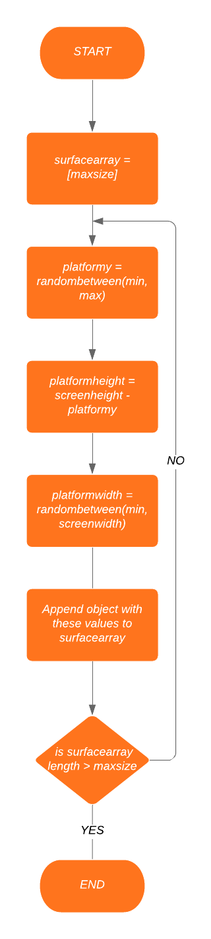

#### Rewinding Time:

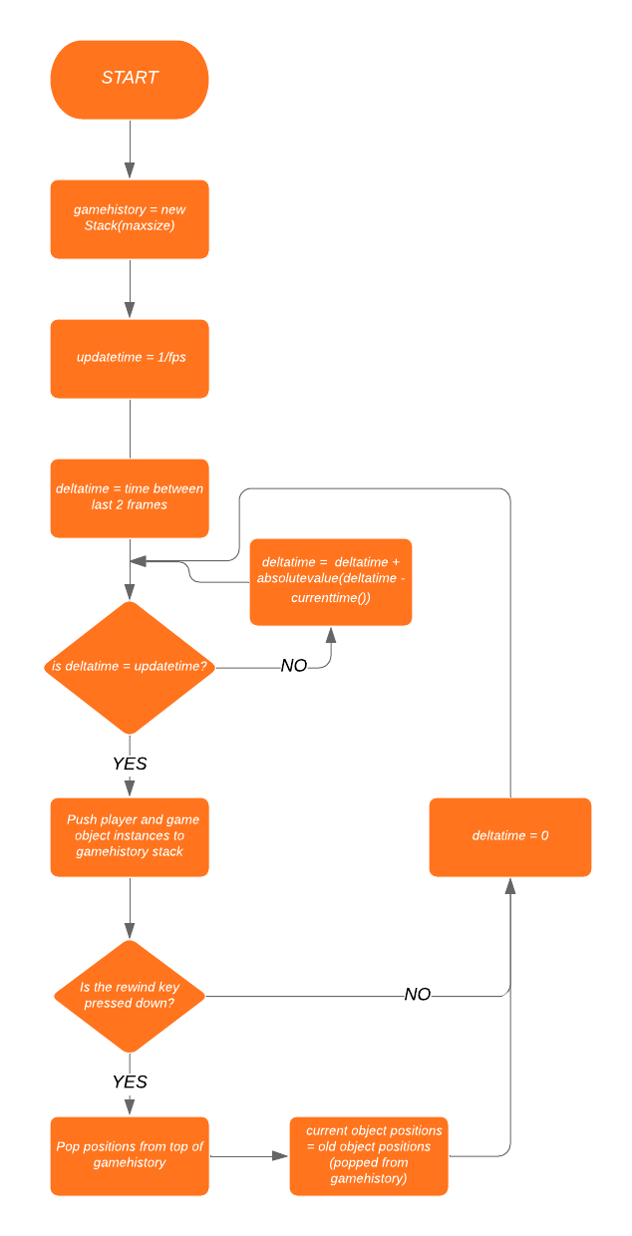

This algorithm is reliant on a stack data structure to get recently added data of positions for each game object and information such as score. The gamehistory stack will always contain the last x amount of frames (determined by the user as having a higher store of history increases how far a player can rewind and therefore affects difficulty).

#### Main Menu:

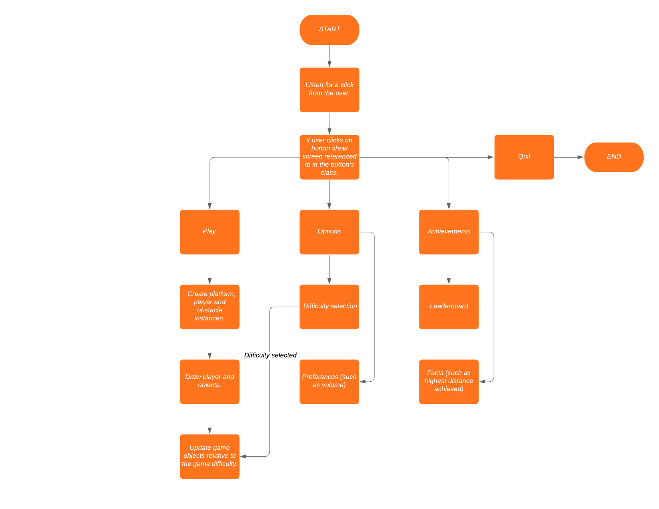

## Pseudocode (Overview of Fundamental Program Elements)

PROCEDURE gameLoop(delay = 1/60, deltatime, starttime, currenttime = 0, spacepressed)

deltatime = absolutevalue(currenttime – starttime) / 1000

if deltatime >= delay:

starttime = currenttime – (deltatime mod fpsinterval)

drawObjects()

updatePositions()

PROCEDURE drawObjects()

platform.Generate()

player.draw()

for each array in objects:

for each item in array:

item.draw()

PROCEDURE updatePositions()

player.update()

PROCEDURE player.update()

player.y = player.y + player.velocity

// keep player above platform they’re under.

if player.yMax > platformunder.yMin:

player.y = platformunder.yMin – player.height

// cause the player to fall.

If player.withinGap() = true OR detectCollision(player, platformunder) = false:  
 this.fall()

Else:

This.vel = 0

// keep the player from going through a platform if they hit its side.

forceposition(player, nextplatform)

FUNCTION detectCollision(obj1, obj2):

If obj1.yMax < obj2.yMin OR obj1.xMax < obj2.xMin OR obj1.xMin > obj2.xMax:

return false

return true

// This algorithm is used to check if a player is NOT colliding with an object, this way only **one of** 3 conditions needs to be met (since a player cannot be under a platform in my game).

PROCEDURE forceposition(obj1, obj2):

If obj1.yMax >= obj2.yMin AND obj1.xMax >= obj2.xMin AND obj1.withinGap = true:

obj1.x = obj2.xMin – obj1.width

FUNCTION Generate(xMin, xMax, dBetween, array):

x = randombetween(xMin, xMax)

array.append(x)

If dBetween + x >= xMax:

return array

else:

return Generate(dBetween + x, xMax, dBetween, array)

// This algorithm is used to generate x positions to place obstacles, the y value being determined by the height of the platform it is placed on. The algorithm finds values between the 2 given x positions, making sure these 2 points are spaced at a minimum of a specified value (dBetween). The algorithm does this recursively until it reaches the biggest possible random x value within the constraints.

Listeners will be used to detect input from the player, the main use will be for allowing the player to jump. When the player’s assigned jump key is pressed, the function assigned to the listener will be called. For the functionality of jumping this will be the player.jump() function which will be called when the input is released. The player.jump() function will simply apply a

value to the player’s velocity.

## Class Diagrams for Main Game objects



## Data Flow Diagram

## IPSO Table

|  |  |  |  |
| --- | --- | --- | --- |
| Input | Processes | Storage | Output |
| Key inputs from user. | Generating platforms.  Generating obstacles.  Placing power ups.  Calculating positions of players and obstacles as a result of adding forces.  Interpreting key input. | Game object instances.  High-Scores  Player facts (e.g longest distance run).  Player’s settings/ game preferences. | Rendering game objects.  Alerting player when they die.  Alerting player when they beat their high score or achieve a high leaderboard ranking. |

## Data Structures

The main data structures that will be used in my program are arrays, booleans and a stack. Arrays will be used to hold objects such as platforms and obstacles making them crucial to the function of my program. My use of an array is slightly different than normal since to conserve memory usage, Platforms and obstacles are removed from the array when they go off screen.

Boolean values are extremely helpful to act as a switch for calling functions and allowing the player to do certain things. An example of this is allowing the player to jump only when they are on a platform. In my program this is done using a boolean value that is only set to true when the player is on the ground.

In my program I use a stack to store the history of the game. The stack holds copies of active game objects so all attributes of the instances can be obtained much easier than storing specific values in separate variables. The length of the stack is determined by the user (as stated before) and does not have an unlimited length as this would use a lot of memory and wouldn’t be necessary.

#### Class Diagram (Stack)

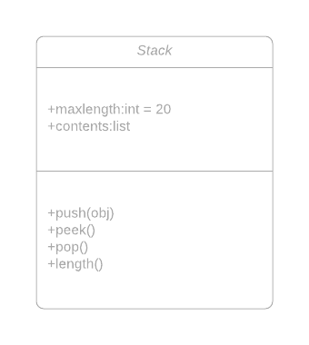

Once the length of the stack = maxlength, the oldest item in the stack is removed, making way for new objects to be added.

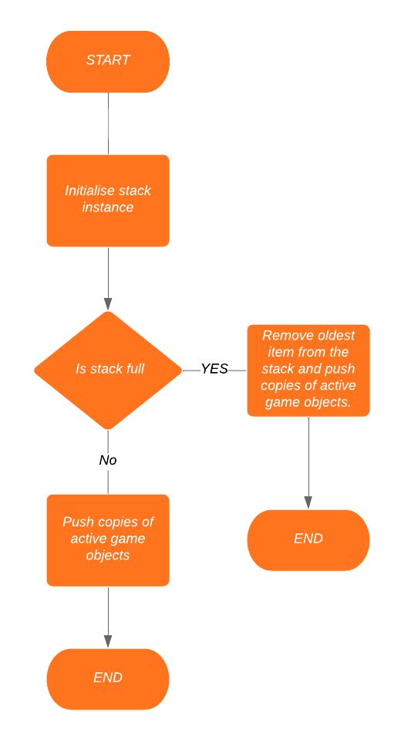

This flowchart shows the process of pushing an item to the history stack. A subroutine will be called every frame to push the active game objects onto the stack, so if the player tries to rewind time, they won’t lose any progress due to the stack not having information at a certain time point.

Data will be stored in a CSV file for high scores, game facts and leaderboards locally. Each user will be able to enter their name which will be attached to the entry of their data in the file. This is needed so alerts for high scores are output to the correct user, if a user doesn’t enter their name then the score will not be saved, and a user will be able to choose if the program should remember a certain name. An online leaderboard would need to be stored in a database as it would need to uniquely identify users and would need a login system.

Details such as settings chosen by the user will be saved into a second CSV file and will be a small file size so there will be no issue with it being stored locally.

## UI Design

The user interface of my game will be designed with simplicity in mind, the use of a simple design makes it easier to navigate and allows for focus on the gameplay. It also makes the game more inviting for a wide range of ages as there aren’t any overwhelming technical terms.

### Main Menu

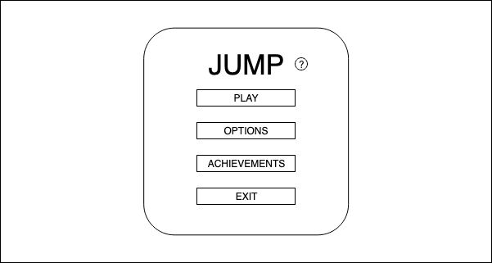

This is the initial screen the player is shown. The player can get to each menu by clicking on one of the buttons on this screen, the “?” button will direct the player to a screen which will give a brief overview of how to play the game. The play button will take them to the game screen, the options will take them to the options screen which contains settings such as volume and game difficulty. Clicking achievements will take the player to the leaderboards page and from there they will have an option to view facts about their gameplay.

### Achievements page

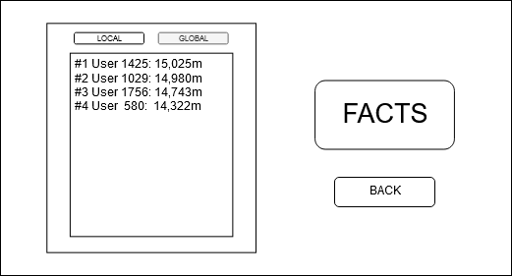

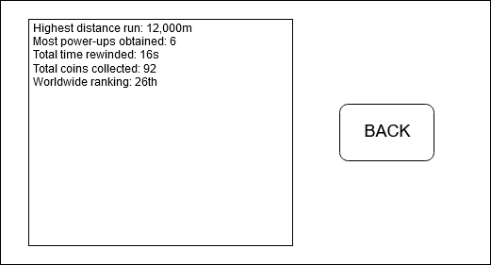

From this screen the user can either display the local or (potentially) global scores submitted to the leaderboard. The local scores will be read from the CSV file and if global scores are implemented they will be retrieved from the database.

This screen will show facts about the player and their achievements in the game. The player is able to see their worldwide ranking here and can find other information such as total coins collected. This can allow users to compare their stats with others and can lead to competition, which is one of my objectives with the game.

### Options Page

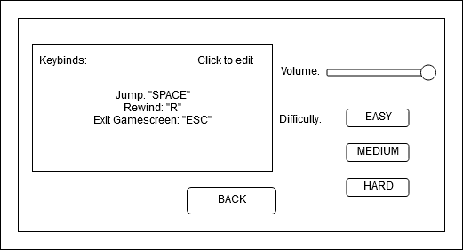

The options screen is where the user is able to customize the game. From this screen the actions that can be performed in the game can be remapped to keys other than the default ones. The player can also alter the difficulty of the game which will in effect increase how quickly the game speeds up, the minimum distance between obstacles etc. The volume of sound effects can also be changed.

### Help Page

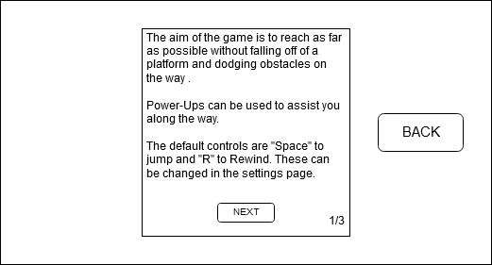The help screen provides a brief overview of the objective of the game and how the user can control the player, it will have multiple pages if needed by the end of the project, and the user can navigate these by using the next button to go through the pages, wrapping back to the first page if next is pressed on the last page and the back button to return to the previous screen.

### Play (Game Screen)

The game screen is where all function of the game takes place. Game objects including platforms, power-ups, coins, the player and obstacles are rendered to this screen. It also displays the background layers (coloured in grey), the amount of coins collected, the current game speed and the distance covered by the player.

## Testing Strategies

I will test my program to make sure it functions as expected for each part. The UI can be tested by making sure all elements such as sliders, buttons and switching pages work correctly. I will ensure that for example sliders affect the corresponding variable rather than just change on screen.

To test the reliability of my algorithms I will play the game many times and see if any errors occur, I can also have other users test my game. Also, to ensure the logic is correct I can substitute common values into my algorithms and see if it produces the expected result.

# Technical Solution

//Game.js

import Layer from "./Layer.js";

import Player from "./Player.js";

import History from "./History.js";

import Platform from "./Platform.js";

import Vector from "./Vector.js";

import Enemy from "./Enemy.js";

import {

sweptAABB,

findIntersect,

detectCollision,

forcepos,

resolveCollision

} from "./collisions.js";

import { createPopulation, getFurthestPlayer } from "./ga.js";

import _ from "lodash";

import Coin from "./coin.js";

import { restartGame, game } from "./main.js";

import { drawLine } from "./Helpers";

require("babel-polyfill");

export default class Game {

//Class that manages all game logic and drawing.

constructor(

state = "RUNNING",

obstacleQuantity = 5,

gamemode = 0,

oldpopulation = [],

generationnumber = 1

) {

//using 16:9 aspect ratio.

this.heightratio = 9;

this.widthratio = 16;

//loading the canvas HTML element into game attributes.

this.screen = document.getElementById("gamescreen");

this.menuOverlay = document.getElementById("overlay");

this.gameOverMenu = {

menu: document.getElementById("gameOver")

};

this.mainMenu = {

menu: document.getElementById("mainMenu")

};

this.pausedMenu = {

menu: document.getElementById("pausedMenu")

};

this.loginPage = {

menu: document.getElementById("loginPage"),

form: document.getElementById("loginForm"),

username: document.getElementById("username")

};

this.difficultySelect = document.getElementById("difficultySelect");

this.modeSelect = document.getElementById("modeSelect");

this.helpPage = document.getElementById("helpPage");

this.scoresPage = document.getElementById("scoresPage");

this.ctx = this.screen.getContext("2d");

this.screen.width =

((window.innerWidth + window.innerHeight) /

(this.heightratio + this.widthratio)) *

this.widthratio;

this.screen.height =

((window.innerWidth + window.innerHeight) /

(this.heightratio + this.widthratio)) *

this.heightratio;

this.screen.style.background = "rgba(032,032,032,0.3)";

this.coins = [];

this.surfacearray = []; //this.initPlatforms();

this.powerups = [];

this.state = state;

this.player;

this.playerName;

this.currenthighScore = JSON.parse(localStorage.getItem("highScore"));

this.scores = localStorage.getItem("Scores");

this.showhighScoreAlert;

this.highScoreAlert = document.getElementById("highScoreAlert");

this.popsize = 30;

this.savedEnemies = oldpopulation;

this.startTime = new Date();

this.t1; //start time to calculate time delta.

this.t2 = 0;

this.deltatime = 0.0;

this.jumpmultiplier = 1;

this.delay = 0;

this.fps = 60;

this.secondsPerFrame = 1 / this.fps;

this.camX = 0;

this.camY = 0;

this.secondsOfHistory = 2;

this.historyLength = this.secondsOfHistory * this.fps; // number of frames held in the history stack

//rewindDuration holds the amount of time the player can rewind in seconds using the set time taken for each frame.

this.maxRewindDuration = 2;

this.playerRewindDuration = 0; // Rewind time starts at 0 so player cannot try to rewind futher than history that is held.

this.rewindregenMultiplier = 0.25; // how qucikly the player regens their rewind time.

this.gamehistory = new History(this.historyLength);

this.gamespeed = 1;

this.platfriction = 1;

this.rewind = false;

this.paused;

this.pop; // result of popping from the history stack

this.platformgap = 250;

this.initialisedObjects = false;

this.powerupDuration = 5;

this.platformMinWidth = this.screen.width / 2;

this.platformMaxWidth = 2 * this.screen.width;

this.platformgapgrowthRate = 0.25;

this.platformgapMax;

this.difficulty;

this.obstaclequantity = obstacleQuantity;

this.population;

this.generationNo = generationnumber;

this.gameMode = gamemode; // gameMode 0 = solo, gameMode 1 = player vs AI.

this.addEventListeners();

}

initialiseObjects() {

this.initPlatforms();

this.initLayers();

this.player = new Player();

this.setDifficulty();

if (this.gameMode === 1) {

//load the stored neural network if game mode is player vs AI.

this.loadNN();

}

if (this.state === "TRAINING") {

// create a population of enemies if there is no stored AI to train it.

if (this.population === undefined) {

this.population = createPopulation(this.popsize);

}

this.player = this.population[0];

}

this.initialisedObjects = true;

this.t1 = Date.now(); //start calculating deltatime.

}

initPlatforms() {

this.startingplat = new Platform(0);

this.surfacearray.push(this.startingplat);

this.surfacearray.push(

new Platform(

this.startingplat.id + 1,

this.obstaclequantity,

this.startingplat.right() + 250

)

);

}

initLayers() {

this.menu = new Layer(

"./static/game_menu.png",

0,

0,

this.camX + this.screen.width / 2 - 1050,

screen.height / 2 - 750,

0,

0,

2100,

1500

);

this.background = new Layer(

"./static/city_background_clean_long.png",

0,

0,

this.camX,

this.camY,

0.7

);

this.background2 = new Layer(

"./static/city_background_clean.png",

0,

0,

this.camX,

this.camY - screen.height / 8,

0.5,

400

);

}

setDifficulty() {

if (!!this.player) {

//if this.player is not false. (accounts for undefined and null)

if (this.difficulty === "hard") {

this.obstaclequantity = 5;

this.player.maxvelocity = 30;

}

if (this.difficulty === "medium") {

this.obstaclequantity = 2;

this.player.maxvelocity = 20;

}

if (this.difficulty === "easy") {

this.obstaclequantity = 0;

this.player.maxvelocity = 15;

}

}

}

update() {

if (this.state === "RUNNING" || this.state === "TRAINING") {

this.t2 = Date.now();

this.deltatime = Math.abs(this.t2 - this.t1) / 1000; // deltatime will equal the time passed since t1 and t2 in seconds.

if (this.initialisedObjects === false) {

this.initialiseObjects();

}

// if (this.deltatime > 0.15) {

// this.deltatime = 0.15;

// }

if (this.deltatime >= this.secondsPerFrame && this.paused !== true) {

// only call update logic if the time passed is bigger or equal to the update rate.

this.t1 = this.t2 - (this.deltatime % this.secondsPerFrame);

if (this.rewind) this.rewindGame();

this.manageCanvas(this.player);

this.drawObjects();

this.updateObjects();

this.drawScore();

// furthestplayer = getFurthestPlayer();

if (this.rewind === false) this.saveCopies();

// distance = 0;

// distance += calcDistance(deltatime);

}

} else if (this.state === "PAUSED") {

//display pause menu.

this.showMenu(this.pausedMenu.menu);

} else if (this.state === "LOGIN") {

this.showMenu(this.loginPage.menu);

} else if (this.state === "GAMEOVER") {

// display game over menu.

if (this.showhighScoreAlert) {

this.highScoreAlert.innerHTML = `NEW HIGHSCORE: ${

this.player.name

}, ${Math.trunc(this.player.score)}m`;

this.highScoreAlert.style.visibility = "visible";

}

this.showMenu(this.gameOverMenu.menu);

} else if (this.state === "MAINMENU") {

//display main menu.

this.showMenu(this.mainMenu.menu);

} else if (this.state === "DIFFICULTYSELECT") {

this.showMenu(this.difficultySelect);

} else if (this.state === "MODESELECT") {

this.showMenu(this.modeSelect);

}

}

updateObjects() {

this.background2.move();

this.background.move();

if (this.gameMode === 0) {

this.updatePlatforms(false);

} else this.updatePlatforms();

this.updateCoins();

this.updatePowerups();

this.updateRewind();

if (this.state === "RUNNING") {

if (this.enemy !== undefined && this.gameMode === 1) this.enemy.update();

this.player.update();

} else if (this.state === "TRAINING") {

this.updatePopulation();

}

// console.log(JSON.stringify(this.surfacearray));

}

updatePlatforms(generatecoins = true) {

for (var object of this.surfacearray) {

object.move();

if (

this.screen.width + this.camX - object.right() >= this.platformgap &&

!object.passedplatgap &&

object.id !== 0

) {

// generate a new platform only when the end of the last one is at the right side of the screen.

this.surfacearray.push(

new Platform(

object.id + 1,

this.obstaclequantity,

object.right() + this.platformgap

)

);

if (Math.random() < 0.5 && generatecoins === true) {

// generate a coin at 50% chance.

var newcoin = new Coin(

object.right() + (this.platformgap / 2 - 25),

object.top() - this.screen.height / 1.5,

50,

50

);

this.coins.push(newcoin);

}

object.passedplatgap = true;

this.newplatform = false;

}

if (object.isOffScreen()) {

//remove platform from array when its off screen

this.surfacearray.shift();

}

}

}

updatePopulation() {

this.player = this.population[0];

for (var item of this.population) {

item.update();

}

if (this.player.score >= 1500) {

if (this.generationNo < 3) {

if (this.population.length > 0) {

// the last enemy alive is pushed to the population for the next generation.

this.savedEnemies.push(this.population[0]);

}

var enemies = this.savedEnemies;

// restartGame();

restartGame("TRAINING", 0, enemies, ++this.generationNo);

} else {

// if there has been 3 generations, the model is saved.

this.saveModel();

restartGame("MAINMENU");

}

}

if (this.player !== undefined) this.updateVelocityPopulation();

}

async saveModel() {

//saves the model to the browser's localstorage

const result = await this.player.nn.model.save("localstorage://my-model-1");

}

async loadNN() {

// fetch("./static/my-model.json").then(function(responseObj) {

// console.log("status: ", responseObj.text());

// });

try {

// tries to retrieve the model from local storage.

const enemyNN = await tf.loadLayersModel("localstorage://my-model-1");

this.enemy = new Enemy();

this.enemy.nn.model = enemyNN;

this.enemy.position.x -= this.screen.width / 8;

} catch (err) {

// if it couldnt be found, the AI will be retrained and that model saved.

console.log("AI must be trained first... /n setting to train mode");

restartGame("TRAINING", 0);

}

}

updateVelocityPopulation() {

//updating the velocity for each member of the population, done in the game class so velocity is not increased as many times as the quantity of the population.

var velocityTotalMAX = this.population.length * this.player.maxvelocity;

var velocityTotal = 0;

for (var enemy of this.population) velocityTotal += enemy.vel.x;

if (velocityTotal < velocityTotalMAX) {

for (var object of this.population) {

object.vel.x += object.velocitygrowthRate;

}

if (this.platformgap < this.platformgapMax) {

this.platformMinWidth += this.platformgapgrowthRate;

this.platformgap += this.platformgapgrowthRate;

}

}

}

updateCoins() {

for (var coin of this.coins) {

coin.update();

}

}

updateRewind() {

// player regens rewind time when they're not in the process of rewinding time

if (this.playerRewindDuration < 2 && this.rewind === false) {

this.playerRewindDuration += this.deltatime * this.rewindregenMultiplier;

}

}

updatePowerups() {

for (var powerup of this.powerups) {

powerup.update();

if (powerup.startTimer) {

// when a powerup is activated its starttimer attribute will be true, deltatime is added until it reaches powerup duration.

powerup.timer += this.deltatime;

}

if (powerup.timer > powerup.duration) {

//powerup time limit reached.

powerup.deactivatePower();

var index = this.powerups.indexOf(powerup);

this.powerups.splice(index, 1);

}

}

}

saveCopies() {

//using Lodash library's clone deep function to create a copy of the player object for use later.

var arr = [

_.cloneDeep(this.player),

_.cloneDeep(this.surfacearray),

_.cloneDeep(this.coins),

this.screen.style.background,

_.cloneDeep(this.powerups)

];

if (this.state === "RUNNING" && this.gameMode === 1) {

// only clones enemy if the game is not in a training state.

arr.push(_.cloneDeep(this.enemy));

}

this.gamehistory.add(arr);

}

rewindGame() {

if (this.gamehistory.stack.length > 0 && this.playerRewindDuration > 0) {

//all game objects are set to the values in the history stack at the point when the player let go of "R".

this.pop = this.gamehistory.pop();

this.player = this.pop[0];

this.surfacearray = this.pop[1];

this.coins = this.pop[2];

this.screen.style.background = this.pop[3];

this.powerups = this.pop[4];

if (this.state === "RUNNING" && this.gameMode === 1)

this.enemy = this.pop[5];

this.playerRewindDuration -= this.secondsPerFrame;

} else {

this.player = this.pop[0];

}

}

drawScore() {

this.ctx.font = "48px Advent Pro";

this.ctx.textAlign = "center";

if (this.player !== undefined) {

if (this.gameMode === 1) {

// draws both the player and enemy's score if it is player vs ai mode.

this.ctx.fillText(

`- Your score: ${Math.trunc(

this.player.score

)}m Enemy score: ${Math.trunc(this.enemy.score)}m-`,

this.screen.width / 2 + this.camX,

this.screen.height / 12

);

} else {

this.ctx.fillText(

`- ${Math.trunc(this.player.score)}m -`,

this.screen.width / 2 + this.camX,

this.screen.height / 12

);

}

}

if (this.player.currentPower !== undefined) {

//draws the player's active power up.

this.ctx.font = "36px Montserrat";

this.ctx.fillText(

`${this.player.currentPower.name.toUpperCase()}`,

this.screen.width / 2 + this.camX,

this.screen.height / 7

);

}

}

drawObjects() {

this.background2.draw();

this.background.draw();

this.drawPlatforms();

this.drawCoins();

this.drawRewindbar();

this.player.draw();

if (this.enemy !== undefined) this.enemy.draw();

if (this.state === "TRAINING") {

for (var item of this.population) {

item.draw();

}

}

}

drawPlatforms() {

for (var i = 0; i < this.surfacearray.length; i++) {

if (this.surfacearray[i].instantiated) {

this.surfacearray[i].draw();

}

}

}

drawCoins() {

if (this.coins.length > 0) {

for (var coin of this.coins) {

coin.draw();

}

}

}

drawRewindbar() {

var ratio = this.playerRewindDuration / this.maxRewindDuration;

var width = (ratio * this.screen.width) / 12;

//fills a bar with the percentage of rewind duration the player has.

this.ctx.fillStyle = "rgb(0,255,125)";

this.ctx.fillRect(

this.screen.width / 2 - this.screen.width / 24 + this.camX,

screen.height / 9.5,

width,

this.screen.height / 64

);

this.ctx.strokeStyle = "black";

this.ctx.strokeRect(

this.screen.width / 2 - this.screen.width / 24 + this.camX,

screen.height / 9.5,

this.screen.width / 12,

this.screen.height / 64

);

this.ctx.fillStyle = "black";

}

pauseGame() {

if (this.state === "RUNNING") {

this.setState("PAUSED");

// this.savedDeltatime = this.deltatime;

} else if (this.state === "PAUSED") {

this.hideMenu(this.pausedMenu.menu);

this.setState("RUNNING");

this.t1 = Date.now();

}

}

unpauseGame() {

this.deltatime = this.savedDeltatime;

this.hideMenu(this.pausedMenu.menu);

this.setState("RUNNING");

this.t1 = Date.now();

}

setState(state) {

this.state = state;

}

hideMenu(menu) {

if (menu === this.gameOverMenu.menu) {

this.highScoreAlert.style.visibility = "hidden";

}

this.menuOverlay.style.visibility = "hidden";

menu.style.visibility = "hidden";

}

showMenu(menu) {

this.menuOverlay.style.visibility = "visible";

if (this.state === "GAMEOVER") {

this.menuOverlay.style.background = "rgba(50,0,0,0.5)";

} else {

this.menuOverlay.style.background = "rgba(32,32,32,0.5)";

}

menu.style.top = this.screen.height / 2 - menu.offsetHeight / 2 + "px";

menu.style.left = window.innerWidth / 2 - menu.offsetWidth / 2 + "px";

menu.style.visibility = "visible";

}

addEventListeners() {

document.body.addEventListener("click", ev => {

if (ev.target.id === "restartBtn") {

this.hideMenu(this.gameOverMenu.menu);

this.hideMenu(this.pausedMenu.menu);

restartGame("LOGIN", this.obstaclequantity, this.gameMode);

}

if (ev.target.id === "playBtn") {

this.hideMenu(this.mainMenu.menu);

this.setState("MODESELECT");

}

if (ev.target.id === "resumeBtn") {

this.unpauseGame();

}

if (ev.target.id === "helpBtn") {

this.setState("HELPMENU");

this.hideMenu(this.mainMenu.menu);

this.showMenu(this.helpPage);

}

if (ev.target.id === "exitBtn") {

this.hideMenu(this.pausedMenu.menu);

this.hideMenu(this.gameOverMenu.menu);

restartGame("MAINMENU");

}

if (ev.target.id === "helpProceed") {

this.hideMenu(this.helpPage);

this.setState("MAINMENU");

}

if (ev.target.id === "backBtn") {

this.setState("MAINMENU");

this.hideMenu(this.scoresPage);

this.hideMenu(this.difficultySelect);

}

if (ev.target.id === "hardBtn") {

this.difficulty = "hard";

this.setState("LOGIN");

this.hideMenu(this.difficultySelect);

}

if (ev.target.id === "mediumBtn") {

this.difficulty = "medium";

this.setState("LOGIN");

this.hideMenu(this.difficultySelect);

}

if (ev.target.id === "easyBtn") {

this.difficulty = "easy";

this.setState("LOGIN");

this.hideMenu(this.difficultySelect);

}

if (ev.target.id === "soloBtn") {

this.gameMode = 0;

this.hideMenu(this.modeSelect);

this.setState("DIFFICULTYSELECT");

}

if (ev.target.id === "pveBtn") {

this.gameMode = 1;

this.hideMenu(this.modeSelect);

this.setState("DIFFICULTYSELECT");

}

if (ev.target.id === "trainAI") {

this.hideMenu(this.modeSelect);

this.obstaclequantity = 0;

this.setState("TRAINING");

}

});

document.getElementById("scoresBtn").addEventListener("click", () => {

//load scores into paragarph element.

this.scores = localStorage.getItem("Scores");

var para = document.getElementById("scores");

if (this.scores !== null) {

para.textContent = "";

var scores = JSON.parse(this.scores);

scores.sort((a, b) => (a.score < b.score ? 1 : -1));

for (var scoreObj of scores) {

var append = `#${scores.indexOf(scoreObj) + 1} User: ${

scoreObj.username

}, Score: ${scoreObj.score} \n`;

para.textContent += append;

para.appendChild(document.createElement("br"));

}

}

this.setState("SCORESMENU");

this.hideMenu(this.mainMenu.menu);

this.showMenu(this.scoresPage);

});

this.loginPage.form.addEventListener("submit", ev => {

ev.preventDefault();

this.playerName = this.loginPage.username.value;

// this.loginPage.username.value = "";

this.hideMenu(this.loginPage.menu);

this.setState("RUNNING");

this.t1 = Date.now();

});

window.addEventListener("keydown", ev => {

if (ev.code === "Space") {

this.player.jump();

this.player.collided = false;

}

if (ev.key === "R" || ev.key === "r") {

this.rewind = true;

}

if (ev.key === "Escape" || ev.key === "Esc") {

this.pauseGame();

}

if (ev.key === "Control") {

this.player.crouch();

}

});

window.addEventListener("keyup", ev => {

if (ev.key === "R" || ev.key === "r") {

this.rewind = false;

}

if (ev.key === "Control") {

this.player.uncrouch();

}

});

}

manageCanvas(target = this.player) {

//setting the camera to follow the player only when it's in its active zone.

this.ctx.setTransform(1, 0, 0, 1, 0, 0);

this.ctx.clearRect(0, 0, this.screen.width, this.screen.height);

const raisespeed = 1.7;

var yactivezone = this.screen.height / 8;

var xactivezone = this.screen.width / 4;

if (target.top() <= yactivezone) {

this.camY = (yactivezone - target.top()) * (1 / raisespeed);

} else this.camY = 0;

if (target.right() >= xactivezone) {

this.camX = Math.abs(xactivezone - target.right());

} else this.camX = 0;

this.ctx.translate(-this.camX, this.camY);

}

static randomInRange(min, max) {

return Math.random() * (max - min) + min;

}

}

//Player.js

import { game } from "./main.js";

import AABB from "./AABB.js";

import { getNormal, drawLine } from "./Helpers";

import Vector from "./Vector";

import { detectCollision, resolveCollision } from "./collisions.js";

import NeuralNet from "./NeuralNetwork";

import * as tf from "@tensorflow/tfjs";

import * as tfvis from "@tensorflow/tfjs-vis";

import Sprite from "./Sprite.js";

import Platform from "./Platform";

// const camX = -player.midpoint().x + screen.width / 2;

export default class Player extends AABB {

constructor(initvel = 5, maxvel = 30) {

super(

game.screen.width / 6 - game.screen.width / 12,

game.surfacearray[0].position.y - (game.screen.height / 16 + 1) - 100,

game.screen.width / 36,

game.screen.height / 16,

5, //surfacearray[0].u * gamespeed * platfriction,

0

);

// this.fallspeed = 9 * gamespeed * deltatime;#

this.initvel = initvel;

this.jumpspeed = 0.04 * game.screen.height * game.gamespeed;

this.gravity = 0.0012 * game.screen.height * game.gamespeed;

this.nextPlatformvar;

this.grabID = true;

this.platformtocheck;

this.collided;

this.lastcollision = null;

this.score = 0;

this.sprite;

this.immune = false;

this.currentPower;

this.velocityMultipliery = 1;

this.velocityMultiplierx = 1;

this.frictionMultiplier = 1;

this.maxvelocity = maxvel;

this.velocitygrowthRate = 0.01;

game.platformgapMax =

game.platformgap +

((this.maxvelocity - this.initvel) / this.velocitygrowthRate) *

game.platformgapgrowthRate;

// this.prevstate = this;

// this.lastPlatformIndex = 0;

}

draw() {

if (this.sprite === undefined) {

this.sprite = this.createSprite();

}

this.sprite.drawSprite();

// super.draw();

}

setScores() {

if (this.name !== "") {

this.score = Math.trunc(this.score);

if (game.scores === "undefined" || game.scores === null) {

var currentScoreArray = [];

}

if (game.scores !== "undefined")

var currentScoreArray = JSON.parse(game.scores);

if (currentScoreArray === null) currentScoreArray = [];

var nameInScores = false;

if (

game.currenthighScore === null ||

this.score > game.currenthighScore.score

) {

game.showhighScoreAlert = true;

}

if (

game.currenthighScore === null ||

game.currenthighScore.score < this.score

) {

var saveString = JSON.stringify({

score: this.score,

username: this.name

});

localStorage.setItem("highScore", saveString);

}

for (var i = 0; i < currentScoreArray.length; i++) {

if (

currentScoreArray[i].username === this.name &&

currentScoreArray[i].score < this.score

) {

nameInScores = true;

currentScoreArray[i].score = this.score;

} else if (currentScoreArray[i].username === this.name) {

nameInScores = true;

}

}

if (nameInScores === false) {

var saveString = {

score: this.score,

username: this.name

};

currentScoreArray.push(saveString);

localStorage.setItem("Scores", JSON.stringify(currentScoreArray));

} else {

localStorage.setItem("Scores", JSON.stringify(currentScoreArray));

}

}

game.setState("GAMEOVER");

}

update() {

//set the players name to username entered in login screen.

if (!this.name) this.name = game.playerName;

//manage scoreboard when player dies.

if (this.top() > game.screen.height) {

this.setScores();

}

//increase landing distance and platform distance with speed.

this.updateVelocity();

this.fall();

this.lastcollision = null;

this.handleCollisions(game.surfacearray);

this.position.y += this.vel.y * this.velocityMultipliery;

this.position.x +=

this.vel.x * this.velocityMultiplierx * this.frictionMultiplier;

this.updateScore(game.deltatime);

// this.updateRewind();

if (this.top() >= screen.height) {

// restartGame();

}

}

updateVelocity() {

if (this.vel.x < this.maxvelocity) {

this.vel.x += this.velocitygrowthRate;

if (game.platformgap < game.platformgapMax) {

game.platformMinWidth += game.platformgapgrowthRate;

game.platformgap += game.platformgapgrowthRate;

}

}

}

fall() {

this.vel.y += this.gravity;

}

jump() {

if (this.collided) {

this.vel.y -= this.jumpspeed;

// this.collided = false;

}

}

crouch() {

if (!this.crouched) {

this.height /= 2;

this.position.y -= this.height / 2;

this.crouched = true;

}

}

uncrouch() {

if (this.crouched === true) {

this.height *= 2;

this.position.y -= this.height;

this.crouched = false;

}

}

createSprite() {

var imgsrc = "./static/26207034.png";

var sprite = new Sprite(10, 2, imgsrc);

return sprite;

}

updateScore(time) {

this.score += time * this.vel.x;

}

handleCollisions(array) {

var count = 0;

var objectcount = 0;

for (var object of array) {

//loops through all objects in a given array and checks if the player object is in collision with it.

// console.log(JSON.stringify(object));

if (object.instantiated) {

objectcount++;

var collisionright = detectCollision(this.bottomright(), object, this);

var collisionleft = detectCollision(this.bottomleft(), object, this);

if (collisionright.val === true) {

this.onCollisionEnter(collisionright);

resolveCollision(this, object, collisionright);

} else if (collisionleft.val === true) {

this.onCollisionEnter(collisionleft);

resolveCollision(this, object, collisionleft);

} else {

count++;

}

}

if (object.obstacles.length > 0) {

objectcount++;

for (var obstacle of object.obstacles) {

var collbottom = detectCollision(this.bottomright(), obstacle, this);

var colltop = detectCollision(this.topright(), obstacle, this);

if (collbottom.val === true && this.immune === false) {

if (obstacle.floorspike === true) {

this.resolveCollisionFloorspike(this, obstacle, collbottom);

var index = object.obstacles.indexOf(obstacle);

object.obstacles.splice(index, 1);

} else {

resolveCollision(this, obstacle, collbottom);

}

// obstacle.colour = "blue";

// this.collided = true;

// if (coll.loc === "left side") {

// savedEnemies.push(

// population.splice(population.indexOf(this), 1)[0]

// );

// }

} else if (colltop.val === true && this.immune === false) {

if (obstacle.floorspike === true) {

this.resolveCollisionFloorspike(this, obstacle, colltop);

var index = object.obstacles.indexOf(obstacle);

object.obstacles.splice(index, 1);

} else {

resolveCollision(this, obstacle, colltop, "top");

}

}

}

}

}

if (count === objectcount) {

this.colour = "black";

this.collided = false;

}

}

resolveCollisionFloorspike(player, object, result) {

this.position.x += this.vel.x * result.intersection.t - 0.1;

this.vel.x /= 2;

// player.vel.x = 0;

}

nextPlatform() {

let nextplatformOBJ;

for (let i = 0; i < surfacearray.length; i++) {

if (game.surfacearray[i].id === this.nextPlatformvar) {

nextplatformOBJ = game.surfacearray[i];

}

}

return nextplatformOBJ;

}

platformUnder() {

for (let i = 0; i < game.surfacearray.length; i++) {

if (

this.right() >= game.surfacearray[i].left() &&

this.left() <= game.surfacearray[i].right() &&

this.bottom() <= game.surfacearray[i].top() &&

game.surfacearray[i].instantiated

) {

return game.surfacearray[i];

}

}

return false;

}

withinGap() {

if (this.platformUnder() === false) {

return true;

} else {

return false;

}

}

newFriction(collision) {

if (collision.object.constructor.name === "Platform") {

// this.velocityMultiplierx = collision.object.friction;

this.frictionMultiplier = collision.object.friction;

}

}

onCollisionEnter(collision) {

this.newFriction(collision);

// if (this.called === undefined) {

// this.called = false;

// }

// if (this.called === false) {

// newFriction();

// this.called = true;

// }

}

}

//Enemy.js

import Player from "./Player.js";

import NeuralNet from "./NeuralNetwork.js";

import { game } from "./main.js";

import { restartGame } from "./main";

import { detectCollision, resolveCollision } from "./collisions.js";

import Vector from "./Vector.js";

export default class Enemy extends Player {

constructor(nnModel = new NeuralNet(5, 4, 2)) {

super();

this.previousplatform;

this.nn = nnModel;

this.outputvalues;

this.width = game.player.width * 2;

this.height = game.player.height * 2;

this.immune = true;

this.stopUpdating = false;

this.colour = "red";

}

draw() {

game.ctx.fillStyle = this.colour;

game.ctx.fillRect(

this.position.x,

this.position.y,

this.width,

this.height

);

//reset the canvas fillstyle.

game.ctx.fillStyle = "black";

}

update() {

//increase landing distance and platform distance with speed.

// this.initvel *= 1.001;

if (this.stopUpdating === false) {

this.makeDecision();

this.fall();

this.handleCollisions(game.surfacearray);

// this.vel.x *= game.deltatime;

// this.vel.y *= game.deltatime;

this.position.y += this.vel.y * this.velocityMultipliery;

this.position.x +=

this.vel.x * this.velocityMultiplierx * this.frictionMultiplier;

if (game.state === "RUNNING") {

this.updateVelocity();

if (this.top() >= game.screen.height) {

this.stopUpdating = true;

document.getElementById("gameOverText").innerText = "You Win!";

}

}

this.updateScore(game.deltatime);

}

if (game.state === "TRAINING") {

if (this.top() >= game.screen.height && game.population.length > 1) {

game.savedEnemies.push(

game.population.splice(game.population.indexOf(this), 1)[0]

);

// game.player = game.population[0];

} else if (

this.top() >= game.screen.height &&

game.population.length === 1

) {

var enemies = this.savedEnemies;

restartGame("RUNNING", 0, enemies, game.generationNo + 1);

}

}

}

findNearestObstacle() {

var smallestDistance = Infinity;

var closestObstacle = null;

if (

game.surfacearray[1] !== undefined &&

game.surfacearray[1].obstacles[0] !== undefined

) {

closestObstacle = game.surfacearray[1].obstacles[0];

}

for (var platform of game.surfacearray) {

if (platform.obstalces !== undefined) {

for (var obstacle of platform.obstacles) {

if (obstacle.position.x - this.position.x < smallestDistance) {

smallestDistance = obstacle.position.x - this.position.x;

closestObstacle = obstacle;

}

}

}

}

return closestObstacle;

}

handleCollisions(arr) {

for (var object of arr) {

var collright = detectCollision(this.bottomright(), object, this);

var collleft = detectCollision(this.bottomleft(), object, this);

if (collright.val === true) {

resolveCollision(this, object, collright);

} else if (collleft.val === true) {

resolveCollision(this, object, collleft);

}

}

if (game.state === "RUNNING") {

var playerCollision = detectCollision(

new Vector(

game.player.position.x,

game.player.position.y + game.player.halfsizeHeight

),

this,

this

);

if (playerCollision.val === true) {

game.setState("GAMEOVER");

}

}

}

findNextPlatform() {

var minDistance = Infinity;

var nextPlat = 0;

var difference;

for (var platform of game.surfacearray) {

difference = platform.left() - this.right();

if (difference < minDistance && difference >= 0) {

minDistance = difference;

nextPlat = platform;

}

}

return nextPlat;

}

findCurrentPlatform() {

for (var platform of game.surfacearray) {

if (this.right() >= platform.left() && this.right() <= this.right()) {

//should really use player.left to check if player is past the right edge but

// since collision is done from right, player is technically off the plat as soon as the right edge goes off.

this.previousplatform = platform;

return platform;

}

}

return 0;

}

jump() {

if (this.collided) {

this.vel.y -= this.jumpspeed;

this.collided = false;

}

}

makeDecision() {

var inputs = [];

//get inputs: xvel, currentx, xpos of nearest obstacle, xend of current platform, xstart of next platform

var currentplatform; // = game.surfacearray[0];

var nextplatform; //= game.surfacearray[1];

// set first input as right x coordinate of player.

inputs[0] = this.right();

//set 2nd input as player's horizontal velocity.

inputs[1] = this.vel.x;

// inputs[2] = 0;

// set 3rd input as left x coordinate of nearest obstacle.

var currentDist = Infinity;

var nearestObstacle = 0;

if (!game.surfacearray[1] === undefined) {

currentDist = game.surfacearray[1].obstacles[0].left() - this.right();

} else {

inputs[4] = 0;

}

//Loop through all platforms

for (var plat of game.surfacearray) {

//find the platform that the player is currently on.

if (

this.left() >= plat.left() &&

this.right() <= plat.right() &&

plat.instantiated

) {

//set current platform to the platform that satisfies conditions.

currentplatform = plat;

}

if (plat.obstacles.length > 0) {

for (var obstacle of plat.obstacles) {

var dist = obstacle.left() - this.right();

if (dist < currentDist && dist >= 0) {

//store obstacle position if it is the current closest in the search

currentDist = dist;

nearestObstacle = obstacle;

// inputs[2] = null;

}

}

}

}

nextplatform =

game.surfacearray[game.surfacearray.indexOf(currentplatform) + 1];

if (currentplatform === undefined) {

currentplatform = 0;

inputs[2] = 0;

} else {

inputs[2] = currentplatform.right();

// if (currentplatform.id !== 0){

// inputs[2] = currentplatform.obstacles[0].left();

// }

}

if (nextplatform === undefined) {

nextplatform = game.surfacearray[0];

}

// if (this.findNextPlatform() !== null) {

// inputs[4] = this.findNextPlatform().left();

// } else {

// inputs[4] = null;

// }

if (nextplatform === 0) {

inputs[3] = 0;

} else {

inputs[3] = nextplatform.left();

}

// inputs[4] = nearestObstacle !== 0 ? nearestObstacle.left() - 100 : 0;

inputs[4] = 0;

var result = this.nn.output(inputs);

result.data().then(x => {

if (x[0] > x[1]) {

this.jump();

}

});

// console.log(result.dataSync());

// if (result.dataSync()[0] > result.dataSync()[1]) {

// // this.jump();

// }

// console.log(this.jumpspeed);

// this.jump();

}

}

//ga.js

import Player from "./Player";

import { game } from "./main.js";

import Game from "./Game.js";

import Enemy from "./Enemy";

export function createPopulation(size = 250, arr = []) {

for (var i = 0; i < size; i++) {

if (game.savedEnemies.length === 0 || game.savedEnemies === undefined) {

arr.push(new Enemy());

} else {

arr.push(Select(game.savedEnemies));

}

}

game.savedEnemies = [];

return arr;

}

export function Select(pop) {

var scoreSum = 0;

for (var i of pop) {

scoreSum += i.score;

}

var rand = Game.randomInRange(0, scoreSum);

var selected;

for (var enemy of pop) {

if (rand - enemy.score < 0) {

selected = enemy;

break;

} else {

rand -= enemy.score;

}

}

var child = new Enemy();

child.nn.model = selected.nn.copy();

child.nn.mutate(0.01);

return child;

}

export function getFurthestPlayer() {

var highestscore = 0;

var target;

for (var p of game.population) {

if (p.score > highestscore) {

highestscore = p.score;

target = p;

}

}

return target;

}

//NeuralNetwork.js

import { game } from "./main";

import _ from "lodash";

import Game from "./Game.js";

// import * as tf from "@tensorflow/tfjs";

// import * as tfvis from "@tensorflow/tfjs-vis";

//import { activation } from "@tensorflow/tfjs-layers/dist/exports_layers";

export default class NeuralNet {

constructor(inNodes, hidNodes, outNodes) {

if (arguments.length === 1) {

this.model = arguments[0].copy();

this.inNodes = arguments[0].inNodes;

this.hidNodes = arguments[0].hidNodes;

this.outNodes = arguments[0].outNodes;

} else {

this.model = NeuralNet.createModel(inNodes, hidNodes, outNodes);

this.inNodes = inNodes;

this.hidNodes = hidNodes;

this.outNodes = outNodes;

}

}

static createModel(inNodes, hidNodes, outNodes) {

return tf.tidy(() => {

const model = tf.sequential();

//add hidden layer

model.add(

tf.layers.dense({

units: hidNodes,

inputShape: [inNodes],

activation: "sigmoid"

})

);

//add output layer

model.add(

tf.layers.dense({

units: outNodes,

activation: "softmax"

})

);

return model;

});

}

output(inputarr) {

return tf.tidy(() => {

const input = tf.tensor2d([inputarr]);

const result = this.model.predict(input);

return result;

});

}

mutate(rate) {

tf.tidy(() => {

var weights = this.model.getWeights();

var newweights = [];

for (var arr of weights) {

var shape = arr.shape;

var values = arr.dataSync().slice();

for (var j of values) {

if (Math.random() < rate) {

j += Game.randomInRange(-0.1, 0.1);

}

}

var newarr = tf.tensor(values, shape);

newweights.push(newarr);

}

this.model.setWeights(newweights);

});

}

copy() {

return tf.tidy(() => {

var model = NeuralNet.createModel(

this.inNodes,

this.hidNodes,

this.outNodes

);

var weights = [];

for (var i of this.model.getWeights()) {

weights.push(i.clone());

}

model.setWeights(weights);

return model;

});

// return _.cloneDeep(this.model);

}

}

//History.js

import { game } from "./main";

export default class History {

//This class is my implementation of a stack that is currently

// used only to check values in the previous frame(s).

constructor(maxhistory) {

this.stack = [];

//defines how many frames of historic values should be stored.

this.maxhistory = maxhistory;

}

add(obj) {

if (this.stack.length < this.maxhistory) {

//Checks if the length of the stack exceeds the maximum history size.

this.stack.push(obj);

} else {

this.stack.shift();

this.stack.push(obj);

}

}

peek() {

// returns the last item added to the stack without removing it.

return this.stack[this.stack.length - 1];

}

pop() {

return this.stack.pop();

}

}

//Layer.js

import { game } from "./main";

// if (player === undefined) {

// var camX = 0;

// } else camX = -player.midpoint().x + screen.width / 2;

export default class Layer {

constructor(

imagefilename,

sx = 0,

sy = 0,

dx = game.camX,

dy = game.camY,

scrollspeed = 1,

offset = 0,

width = game.screen.width,

height = game.screen.height

) {

this.src = imagefilename;

this.sx = sx + offset;

this.sy = sy;

this.dx = dx;

this.dy = dy;

this.scrollspeed = scrollspeed;

this.width = width;

this.height = height;

this.pointer = offset;

this.image = Layer.createImage(this.src);

this.getX = function() {

// pointer points to the starting x value of the image to be displayed.

// the pointer increases by "scrollspeed" and as when the pointer

// reaches a number higher than the screen's width, it will wrap back to the starting value

// this creates the scrolling illusion.

this.pointer = this.pointer % (this.image.width - game.camX);

return this.pointer;

};

this.draw = function(

image = this.image,

sx = this.sx,

sy = this.sy,

swidth = this.width,

sheight = this.image.height,

dx = this.dx + game.camX,

dy = this.dy,

dwidth = this.width,

dheight = this.height

) {

// img to draw, sourcex, sourcey, source width, source height, destx, desty, destwidth, destheight

game.ctx.drawImage(

image,

sx,

sy,

swidth,

sheight,

dx,

dy,

dwidth,

dheight

);

};

this.move = function() {

// moves the source x position by 0 if the camera is at the starting point, but by the scrollspeed if the camera is following the player.

this.sx += game.camX === 0 ? 0 : this.scrollspeed;

// this.dx -= this.scrollspeed;

// this.pointer += this.scrollspeed * 5;

};

}

static drawImage(

image = this.image,

sx = this.sx,

sy = this.sy,

swidth = this.width,

sheight = this.image.height,

dx = this.dx + game.camX,

dy = this.dy,

dwidth = this.width,

dheight = this.height

) {

// console.table(image);

game.ctx.drawImage(image, sx, sy, swidth, sheight, dx, dy, dwidth, dheight);

}

static createImage(src) {

if (src !== undefined && src.constructor.name !== "Array") {

var img = new Image();

img.addEventListener("load", () => {});

//require() must be called on all source paths so parcel bundler knows to include these files in the compiled package.

//it is not possible to use variables for this process as require statements are compiled first and before variables are initialised.

if (src === "./static/city_background_clean_long.png") {

src = require("./static/city_background_clean_long.png");

} else if (src === "./static/city_background_clean.png") {

src = require("./static/city_background_clean.png");

} else if (src === "./static/game_menu.png") {

src = require("./static/game_menu.png");

} else if (src === "./static/26207034.png") {

src = require("./static/26207034.png");

} else if (src === "./static/saw-blade.png") {

src = require("./static/saw-blade.png");

} else if (src === "./static/gold_coin_round_blank_1.png") {

src = require("./static/gold_coin_round_blank_1.png");

} else if (src === "./static/gold_coin_round_blank_2.png") {

src = require("./static/gold_coin_round_blank_2.png");

} else if (src === "./static/gold_coin_round_blank_3.png") {

src = require("./static/gold_coin_round_blank_3.png");

} else if (src === "./static/gold_coin_round_blank_4.png") {

src = require("./static/gold_coin_round_blank_4.png");

} else if (src === "./static/gold_coin_round_blank_5.png") {

src = require("./static/gold_coin_round_blank_5.png");

} else if (src === "./static/gold_coin_round_blank_6.png") {

src = require("./static/gold_coin_round_blank_6.png");

} else if (src === "./static/metal-spikes.png") {

src = require("./static/metal-spikes.png");

} else if (src === "./static/metal-spike-block.png") {

src = require("./static/metal-spike-block.png");

} else if (src === "./static/orb_1.png") {

src = require("./static/orb_1.png");

} else if (src === "./static/orb_2.png") {

src = require("./static/orb_2.png");

} else if (src === "./static/orb_3.png") {

src = require("./static/orb_3.png");

} else if (src === "./static/orb_4.png") {

src = require("./static/orb_4.png");

} else if (src === "./static/orb_5.png") {

src = require("./static/orb_5.png");

} else if (src === "./static/orb_6.png") {

src = require("./static/orb_6.png");

} else if (src === "./static/potion1_3.png") {

src = require("./static/potion1_3.png");

}

img.src = src;

return img;

}

}

}

//main.js

import Game from "./Game";

export var game = new Game("MAINMENU", 0);

export function startGame() {

//call update function where all game logic is ran.

game.update();

//continually call the start game function using requestAnimationFrame since it provides useful information such as a timestamp and fixes common recursion error.

requestAnimationFrame(startGame);

}

export function restartGame(

state = "RUNNING",

obstaclequantity = 5,

gamemode = 0,

savedenemies = [],

genNo = 1

) {

// create a new game instance when restart game is called, using the export keyword, it can be called from any other file.

game = new Game(state, obstaclequantity, gamemode, savedenemies, genNo);

console.log("restarted");

}

startGame();

//Obstacle.js

import AABB from "./AABB.js";

import Sprite from "./Sprite.js";

import Blade from "./blade.js";

import { PowerUp } from "./powerup.js";

import { game } from "./main.js";

import {

thresholdedReLU,

Layer

} from "@tensorflow/tfjs-layers/dist/exports_layers";

import { detectCollision } from "./collisions.js";

import Vector from "./Vector.js";

export default class Obstacle extends AABB {

constructor(

id,

x,

y,

width,

height,

xvel,

src,

imageWidth,

imageHeight,

floorspike = false

) {

super(x, y, width, height, xvel, 0);

this.id = id;

this.instantiated = false;

this.sprite = this.createSprite(src, imageWidth, imageHeight);

this.floorspike = floorspike;

this.collisions = true;

if (Math.random() < 0.5 && !this.floorspike) {

// this.blade = this.createBlade();

this.createPowerUp();

} else {

this.blade = null;

}

}

draw() {

this.sprite.drawSprite(false);

// super.draw();

}

move() {

// if (this.position.x === game.surfacearray[0].coordinates[0]))

// if (this.blade !== null) this.blade.update();

// this.handleCollisions();

// this.sprite.drawSprite();

super.move();

}

createSprite(src, imageWidth, imageHeight) {

return new Sprite(

1,

1,

src,

this.left(),

this.top(),

this.width,

this.height,

0,

0,

imageWidth,

imageHeight,

false

);

}

handleCollisions() {

if (this.collisions === true) {

var result = detectCollision(

new Vector(

this.position.x,

this.position.y + (this.height - this.halfsizeHeight)

),

game.enemy,

game.enemy

);

if (result.val === true) {

this.vel.addForce(game.enemy.vel);

}

}

}

createBlade() {

var blade = new Blade(

this.midpoint().x - 25,

this.position.y - this.height - 50,

50,

50,

this.vel.x,

0.04 * screen.height,

this

);

return blade;

}

createPowerUp() {

var newpowerup = new PowerUp(

this.midpoint().x - 25,

this.position.y - this.height,

50,

50,

this.vel.x,

this

);

game.powerups.push(newpowerup);

}

}

//Platform.js

import AABB from "./AABB.js";

import Obstacle from "./Obstacle.js";

import { drawLine } from "./Helpers";

import { game } from "./main.js";

import Vector from "./Vector";

import { getNormal, subtract } from "./Vector.js";

import Game from "./Game.js";

export default class Platform extends AABB {

constructor(

pId = 0,

//generateobstacles = true,

obstacleQuantity = 5,

px = game.screen.width / 6 + game.screen.width / 72 - game.screen.width / 2,

py = Game.randomInRange(

game.screen.height / 2,

game.screen.height - game.screen.height / 8

),

pwidth = Game.randomInRange(game.platformMinWidth, game.platformMaxWidth),

pheight = game.screen.height - py,

pvel = 0,

pcoordlimit = 3

) {

super(px, py, pwidth, pheight, pvel, 0);

this.uv = pvel;

this.instantiated = false;

this.coordinates = [];

this.obstacles = [];

this.landingDistance = this.width / 12;

this.coordinateLimit = pcoordlimit;

this.obstacleDistance = this.landingDistance;

this.obstacleWidth = Game.randomInRange(100, 200); // change so obstacle width is not constant from initialisation

this.obstacleHeight = 50;

this.obstacleQuantity = obstacleQuantity;

this.id = pId;

this.passedplatgap = false;

this.friction = this.getFriction();

this.objectDistance;

}

getFriction() {

var frictionvalues = [1];

// var frictionvalues = [0.8, 0.9, 0.65, 0.4];

// var frictionvalues = [1, 1, 1, 1, 1, 1, 1, 0.7, 1.2, 0.8];

return frictionvalues[

Math.floor(Game.randomInRange(0, frictionvalues.length))

];

}

getCoords(xMin, xMax, d, arrayy) {

//recursive function which finds x values that satisfy the constraints passed in.

// a random x value between a min and max value is generated.

// if the minimum distance between each obstacles + the generated x value

// is bigger than the maximum possible value, that single value will be returned.

// if not, the new distance of the generated x value addded to the minimum distance between obstacles

// is passed back into the function with the original maximum value

var x = Game.randomInRange(xMin, xMax);

if (d + x >= xMax) {

return arrayy;

} else {

arrayy.push(x);

return this.getCoords(d + x, xMax, d, arrayy);

}

}

isOffScreen() {

if (this.right() <= game.camX) {

return true;

} else return false;

}

placeObstacles(obsHeight, obsWidth) {

for (var i = 0; i < this.coordinates.length; i++) {

//loops through each generated coordinate and creates an obstacle object.

if (this.obstacles.length < this.obstacleQuantity) {

var random = Game.randomInRange(0, 1);

if (random > 0.5) {

var newobj = new Obstacle(

i,

this.coordinates[i],

this.position.y - obsHeight,

obsWidth,

obsHeight,

this.vel.x,

"./static/metal-spikes.png",

256,

64,

true

);

// newobj.position.x -= newobj.width;

} else if (random < 0.5) {

var newobj = new Obstacle(

i,

this.coordinates[i],

this.position.y -

(obsHeight +

Game.randomInRange(

game.player.height / 2,

game.player.height + screen.height / 16

)),

obsWidth,

obsHeight,

this.vel.x,

"./static/metal-spike-block.png",

256,

128

);

// newobj.position.x -= newobj.width;

}

this.obstacles.push(newobj);

} else {

break;

}

}

}

draw() {

super.draw();

this.generateObstacles();

for (var i of this.obstacles) {

i.draw();

}

}

generateObstacles() {

if (this.coordinates.length === 0 && this.instantiated && this.id !== 0) {

//generates obstacles for instantiated platforms.

var min = this.left() + this.obstacleWidth + this.landingDistance;

var max = this.right() - (this.obstacleWidth + this.landingDistance);

this.objectDistance = game.player.width + 100 + this.obstacleWidth;

this.coordinates = this.getCoords(min, max, this.objectDistance, []);

this.coordinates = this.coordinates.sort();

if (this.coordinates[0] - min > this.objectDistance) {

this.coordinates = this.getCoords(

min,

this.coordinates[0],

this.objectDistance,

this.coordinates

);

}

this.placeObstacles(this.obstacleHeight, this.obstacleWidth);

}

}

move() {

this.vel.x = this.uv * game.gamespeed * game.platfriction;

for (var i of this.obstacles) {

i.move();

}

this.instantiated = true;

super.move();

}

}

//powerup.js

import AABB from "./AABB";

import { game } from "./main";

import { detectCollision } from "./collisions";

import Sprite from "./Sprite";

import Game from "./Game.js";

export class PowerUp extends AABB {

constructor(spawnX, spawnY, width, height, xvel, parentobj) {

super(spawnX, spawnY, width, height, xvel, 0);

this.powers = [

this.reducedDistance,

this.obstacleImmunity,

this.halfSpeed,

this.rewindtimeRefill

];

this.power = this.getPower();

this.parent = parentobj;

this.startTimer = false;

this.timer = 0;

this.duration = 5;

this.sprite = this.createSprite();

}

createSprite() {

return new Sprite(

1,

1,

[

"./static/orb_1.png",

"./static/orb_2.png",

"./static/orb_3.png",

"./static/orb_4.png",

"./static/orb_5.png",

"./static/orb_6.png"

],

this.left(),

this.top(),

this.width,

this.height,

0,

0,

318,

318,

false

);

}

update() {

if (this.sprite !== undefined) this.sprite.drawSprite(true);

this.handleCollisions();

super.move();

// super.draw();

}

getPower() {

return this.powers[Math.floor(Game.randomInRange(0, this.powers.length))];

}

handleCollisions() {

var collisionright = detectCollision(game.player.bottomright(), this);

var collisionleft = detectCollision(game.player.bottomleft(), this);

if (collisionright.val === true || collisionleft.val === true) {

this.activatePower();

}

}

activatePower() {

this.power();

game.screen.style.background = "rgba(0,255,0,0.3)";

game.player.currentPower = this.power;

this.startTimer = true;

}

deactivatePower() {

if (this.power === this.reducedDistance) {

game.platformgap *= 2;

} else if (this.power === this.obstacleImmunity) {

game.player.immune = false;

} else if (this.power === this.halfSpeed) {

game.player.gravity *= 2;

game.player.velocityMultiplierx *= 2;

game.player.velocityMultipliery *= 2;

game.enemy.gravity *= 2;

game.enemy.velocityMultiplierx *= 2;

game.enemy.velocityMultipliery *= 2;

}

this.startTimer = false;

game.screen.style.background = "rgba(32,32,32,0.3)";

game.player.currentPower = undefined;

}

reducedDistance() {

if (game.player.currentPower !== this.reducedDistance) {

game.platformgap = game.platformgap / 2;

}

}

obstacleImmunity() {

game.player.immune = true;

}

halfSpeed() {

if (game.player.currentPower !== this.halfSpeed) {

game.player.gravity /= 2;

game.player.velocityMultiplierx /= 2;

game.player.velocityMultipliery /= 2;

game.enemy.gravity /= 2;

game.enemy.velocityMultiplierx /= 2;

game.enemy.velocityMultipliery /= 2;

}

// player.vel.scale(0.5);

}

rewindtimeRefill() {

game.playerRewindDuration = 2;

}

}

//sprite.js

import { game } from "./main";

import Layer from "./Layer";

export default class Sprite extends Layer {

constructor(

cols,

rows,

src = undefined,

dx = game.player.left(),

dy = game.player.top(),

dw = game.player.width,

dh = game.player.height,

xoffset = 20,

yoffset = 240,

sheetWidth = 955,

sheetHeight = 222,

spritesheet = true

) {

super(src, 0, 0, dx, dy, 0, 0, dw, dh);

this.cols = cols;

this.rows = rows;

this.frameWidth = sheetWidth / cols;

this.frameHeight = sheetHeight / rows;

this.currentFrame = 0;

this.updateRate = 1;

this.waited = 0;

this.sxoffset = xoffset;

this.syoffset = yoffset;

this.spritesheet = spritesheet;

this.rowSwitch = 0b0; //value of 1 indicates to switch to 2nd row of spritesheet.

this.images = [];

this.initialised = false;

this.imagePointer = 0;

this.timeElapsed = 0;

}

init() {

if (this.src.constructor.name === "Array") {

for (var path of this.src) {

var img = Layer.createImage(path);

this.images.push(img);

}

}

this.initialised = true;

}

drawSprite(update = true) {

if (this.src.constructor.name === "String") {

Layer.drawImage(

this.image,

this.sx + this.sxoffset,

this.sy + this.syoffset,

this.frameWidth,

this.frameHeight,

this.dx,

this.dy,

this.width,

this.height

);

} else if (this.src.constructor.name === "Array") {

if (this.initialised === false) {

this.init();

}

// console.log(this.images[this.imagePointer]);

Layer.drawImage(

this.images[this.imagePointer],

this.sx + this.sxoffset,

this.sy + this.syoffset,

this.frameWidth,

this.frameHeight,

this.dx,

this.dy,

this.width,

this.height

);

}

if (update === true) {

this.updateSprite();

}

}

updateSprite(updaterate = 240) {

// game.ctx.clearRect(game.camX, game.camY, screen.width, screen.height);

var updaterateSeconds = (game.secondsPerFrame * updaterate) / 1000;

if (this.spritesheet === true) {

if (this.currentFrame % this.cols === 0) {

// flip the current value using bitwise XOR

this.rowSwitch = this.rowSwitch ^ 0b1;

}

if (this.rowSwitch === 0b0) {

// set the source Y value to 0 to take sprites from the first row of the spritesheet.

this.sy = 0;

} else if (this.rowSwitch === 0b1) {

// set the source Y value to 120 to take sprites from the second row of the spritesheet.

this.sy = 120;

}

this.currentFrame = ++this.currentFrame % this.cols;

this.sx = this.currentFrame * this.frameWidth;

this.dx = game.player.left();

this.dy = game.player.top();

} else if (this.src.constructor.name === "Array") {

this.imagePointer = ++this.imagePointer % this.src.length;

}

}

}

// } else {

// this.timeElapsed += game.deltatime;

// }

//

// }

// vector.js

export default class Vector {

constructor(vx, vy) {

this.x = vx;

this.y = vy;

// if (vx === NaN) console.log("bruh");

// try {

// if (vx === NaN) throw "Invalid input";

// if (vy === NaN) throw "Invalid input";

// } catch (error) {

// console.error(error);

// }

}

resultant(vector) {

return new Vector(this.x + vector.x, this.y + vector.y);

}

modulus() {

return Math.sqrt(this.x * this.x + this.y * this.y);

}

normalized() {

return new Vector(this.x / this.modulus(), this.y / this.modulus());

}

dotprod(vector) {

return (

this.normalized().x * vector.normalized().x +

this.normalized().y * vector.normalized().y

);

}

addForce(vector) {

// Add a vector to the current vector instance

this.x += vector.x;

this.y += vector.y;

}

scale(scalefactor) {

this.x *= scalefactor;

this.y *= scalefactor;

}

scaled(sf) {

// return new Vector(this.x * sf, this.y * sf);

var scalar = sf / this.modulus();

return new Vector(this.x * scalar, this.y * scalar);

}

distance(vector) {

return Math.sqrt(

(vector.x - this.x) * (vector.x - this.x) +

(vector.y - this.y) * (vector.y - this.y)

);

}

}

export function getNormal(A, B) {

var dx = B.x - A.x;

var dy = B.y - A.y;

return new Vector(dy, -dx);

}

export function subtract(vectorA, vectorB) {

return new Vector(vectorB.x - vectorA.x, vectorB.y - vectorA.y);

}

//aabb.js

import { game } from "./main.js";

import Game from "./Game.js";

import Vector from "./Vector.js";

// import Obstacle from "./Obstacle.js";

export default class AABB {

// class for axis aligned bounding boxes.

//all collisions will be approximated using bounding boxes.

constructor(rx, ry, rwidth, rheight, xvel, yvel) {

this.position = new Vector(rx, ry);

this.width = rwidth;

this.height = rheight;

this.vel = new Vector(xvel, yvel);

this.halfsizeWidth = this.width / 2;

this.halfsizeHeight = this.height / 2;

this.colour = "black";

this.x = rx;

this.y = ry;

}

right() {

//returns the right position of the bounding box

return this.position.x + this.width;

}

top() {

//returns the top position of the bounding box

return this.position.y;

}

left() {

//returns the left position of the bounding box

return this.position.x;

}

bottom() {

//returns the bottom position of the bounding box

return this.position.y + this.height;

}

move() {

//moves the box by the velocity passed into the constructor. (on x-axis)

this.position.x -= this.vel.x; //* game.platfriction;

}

topleft() {

//returns a Vector(x,y) object containing the co-ordinates for the top left of the bounding box instance.

return new Vector(this.position.x, this.position.y);

}

topright() {

//returns a Vector(x,y) object containing the co-ordinates for the top right of the bounding box instance.

return new Vector(this.position.x + this.width, this.position.y);

}

bottomleft() {

//returns a Vector(x,y) object containing the co-ordinates for the bottom left of the bounding box instance.

return new Vector(this.position.x, this.position.y + this.height);

}

bottomright() {

//returns a Vector(x,y) object containing the co-ordinates for the bottom right of the bounding box instance.

return new Vector(

this.position.x + this.width,

this.position.y + this.height

);

}

midpoint() {

//returns a Vector(x,y) object containing the co-ordinates for the mid point of the bounding box instance.

return new Vector(

this.position.x + this.halfsizeWidth,

this.position.y + this.halfsizeHeight

);

}

draw() {

//draws the bounding box to the canvas with the colour passed in as a parameter in the constructor.

game.ctx.fillStyle = this.colour;

game.ctx.fillRect(

this.position.x,

this.position.y,

this.width,

this.height

);

//reset the canvas fillstyle.

game.ctx.fillStyle = "black";

}

}

// coin.js

import { PowerUp } from "./powerup";

import { game } from "./main.js";

import { detectCollision } from "./collisions";

import Sprite from "./Sprite";

export default class Coin extends PowerUp {

constructor(spawnX, spawnY, width, height) {

super(spawnX, spawnY, width, height, 0);

this.value = 10;

this.sprite = new Sprite(

1,

1,

[

"./static/gold_coin_round_blank_1.png",

"./static/gold_coin_round_blank_2.png",

"./static/gold_coin_round_blank_3.png",

"./static/gold_coin_round_blank_4.png",

"./static/gold_coin_round_blank_5.png",

"./static/gold_coin_round_blank_6.png"

],

this.left(),

this.top(),

this.width,

this.height,

0,

0,

50,

50,

false

);

}

update() {

// check collisions.

var collisionbottom = detectCollision(game.player.bottomright(), this);

var collisiontop = detectCollision(game.player.topright(), this);

if (collisionbottom.val === true || collisiontop.val === true) {

//if player landed on a coin, add its value to the score and delete the coin.

this.collect();

}

if (this.right() < game.camX) {

// delete the coin if it goes off screen.

var index = game.coins.indexOf(this);

game.coins.splice(index, 1);

}

}

draw() {

this.sprite.drawSprite(true);

}

collect() {

// adds the value of the coin to the player's score.

game.player.score += this.value;

var index = game.coins.indexOf(this);

game.coins.splice(index, 1);

}

}

// collisions.js

import Vector from "./Vector";

import { game } from "./main";

import { drawLine } from "./Helpers";

export function sweptAABB(cornervector, object, aabb1 = game.player) {

if (cornervector.constructor.name !== "Vector") console.trace();

if (arguments[3] !== undefined) {

// if the function is given a 4th parameter it is assigned as the velocity to check.

var vel = arguments[3];

} else {

var vel = aabb1.vel;

}

// each check (c1, c2, c3, c4) takes 5 paraameters, the first being the start point of the first line, 2nd parameter is the

// end point of the first line, 3rd is the start point of the second line and 4th is the end point of the second line.

// the 5th parameter is the object which collisions are checked against, this is used to identify where collisions where detected in other parts of the code.

var c1 = findIntersect(

cornervector,

cornervector.resultant(vel),

object.bottomleft(),

object.topleft(),

object

);

// the findIntersect() function returns an object containing the result of the collision (true or false), the intersection point at which they meet,

// the side of the AABB that the collision was found at and the type of object (e.g player, platform, obstacle) it also returns the original object that collisions were checked on.

if (!c1 === false && c1 !== undefined) {

return {

val: true,

intersection: c1,

loc: "left side",

objtype: object.constructor.name,

object: object

};

}

var c2 = findIntersect(

cornervector,

cornervector.resultant(vel),

object.topleft(),

object.topright(),

object

);

if (!c2 === false && !c2 !== undefined) {

return {

val: true,

intersection: c2,

loc: "top",

objtype: object.constructor.name,

object: object

};

}

var c3 = findIntersect(

cornervector,

cornervector.resultant(vel),

object.topright(),

object.bottomright(),

object

);

if (!c3 === false && c3 !== undefined) {

return {

val: true,

intersection: c3,

loc: "right side",

objtype: object.constructor.name,

object: object

};

}

var c4 = findIntersect(

cornervector,

cornervector.resultant(vel),

object.bottomleft(),

object.bottomright(),

object

);

if (!c4 === false && c4 !== undefined) {

return {

val: true,

intersection: c4,

loc: "bottom",

objtype: object.constructor.name,

object: object

};

} else return { val: false };

}

export function findIntersect(p1, p2, p3, p4, object) {

// lines in form Ax +By = C

// defines line 1: a1x + b1y = c1 and line 2: a2x + b2y = c2.

// this function finds the intersection between 2 lines

// by equating the lines and rearanging for x and y the point of intersection is found.

var a1 = p2.y - p1.y,

b1 = p1.x - p2.x,

c1 = a1 * p1.x + b1 * p1.y,

a2 = p4.y - p3.y,

b2 = p3.x - p4.x,

c2 = a2 * p3.x + b2 * p3.y,

den = a1 * b2 - a2 * b1,

x = (c1 * b2 - c2 * b1) / den,

y = (c2 * a1 - a2 * c1) / den;

// drawLine(p1, p2, "green");

// drawLine(p3, p4, "yellow");

if (den === 0) {

return false;

}

//fx and fy are the fraction/decimal of the velocity at which the collision was detected.

var fx = (x - p1.x) / (p2.x - p1.x);

var fy = (y - p1.y) / (p2.y - p1.y);

var fx2 = (x - p3.x) / (p4.x - p3.x);

var fy2 = (y - p3.y) / (p4.y - p3.y);

// only values of fx and fy that are between 1 and 0 are accepted as this means that the collision happened within 1 frame of position change (velocity).

//if values out of the range 1 and 0 were accepted, collisions would be found for the whole line equation of the velocity rather than

//just the segement representing how much the player moves per frame.

if (

fx >= 0 &&

fx <= 1 &&

((fx2 >= 0 && fx2 <= 1) || (fy2 >= 0 && fy2 <= 1))

) {

return { point: new Vector(x, y), t: fx };

}

if (

fy >= 0 &&

fy <= 1 &&

((fx2 >= 0 && fx2 <= 1) || (fy2 >= 0 && fy2 <= 1))

) {

return { point: new Vector(x, y), t: fy };

} else return false;

}

export function detectCollision(corner, platform, aabb1) {

// console.log(platform);

//calls the continuous collision detection function above.

var result = sweptAABB(corner, platform, aabb1);

if (result === undefined) return false;

return result;

}

export function resolveCollision(player, object, result, corner = "bottom") {

if (result.loc === "top" && corner === "bottom") {

// player's velocity is multiplied by the t value of the intersection.

// which indicates the fraction of velocity needed to be added so the player will move to the object but not past it .

player.vel.y *= result.intersection.t;

player.vel.y -= 0.1;

player.position.y += player.vel.y;

//velocity set to 0 after the collision so player cannot keep moving through the wall it collided with.

player.vel.y = 0;

player.collided = true;

//saves this collision as the player's most recent collision.

player.lastcollision = result;

}

if (result.loc === "bottom") {

// player's velocity is multiplied by the t value of the intersection.

// which indicates the fraction of velocity needed to be added so the player will move to the object but not past it .

player.vel.y *= result.intersection.t;

player.vel.y += 0.1;

player.position.y += player.vel.y;

player.vel.y = 0;

}

if (result.loc === "left side" && object.floorspike !== false) {

// collision response for all objects other than floating platforms.

player.vel.x *= result.intersection.t;

player.vel.x -= 0.1;

player.position.x += player.vel.x;

player.vel.x = 0;

}

if (object.floorspike !== undefined && object.floorspike === false) {

//specific collision response for floating platforms.

//player is slowed by half their velocity if they hit the sides or bottom.

if (result.loc === "left side") {

player.position.x += player.vel.x * result.intersection.t - 0.1;

player.vel.x /= 2;

}

if (result.loc === "bottom") {

player.vel.x /= 2;

}

}

}

//blade.js

import AABB from "./AABB";

import Sprite from "./Sprite";

import { game } from "./main";

import { detectCollision, resolveCollision } from "./collisions";

export default class Blade extends AABB {

constructor(

x,

y,

w,

h,

xvel,

impulse,

parentobj,

gravity = 0.0024 * game.screen.height

) {

super(x, y, w, h, xvel, 0);

this.impulse = impulse;

this.gravity = gravity;

this.parent = parentobj;

this.sprite = this.createSprite();

}

draw() {

//draws the blade sprite and assigns its x and y values to the current blade instance.

this.sprite.drawSprite(false);

this.sprite.dx = this.left();

this.sprite.dy = this.top();

}

update() {

//called every frame, causes the blade to shoot up and down from its parent obstacle.

this.vel.y += this.gravity;

this.handleCollisions();

this.position.y += this.vel.y;

this.draw();

}

createSprite() {

return new Sprite(

1,

1,

"./static/saw-blade.png",

this.position.x,

this.top(),

this.width,

this.height,

0,

0,

1907,

1920

);

}

handleCollisions() {

var coll = detectCollision(this.bottomright(), this.parent);

if (coll.val === true && coll.loc === "bottom") {

//move the player to the point at which it collides with the obstacle.

this.vel.y *= coll.intersection.t;

this.vel.y += 0.1;

this.position.y += this.vel.y;

//shoot the obstacle away from the obstacle parent.

this.vel.y -= this.impulse;

}

}

}

## 4 – Testing:

|  |  |  |  |  |  |
| --- | --- | --- | --- | --- | --- |
| No. | Test Description | Method | Expected result | Result | Video link |
|  |  | **--MENU TESTS--** |  |  |  |
|  | Testing score button on main menu before launching the game | Clicking the button and observing the output | Back button will be visible with no entries | As expected. | <https://youtu.be/WyPBGLcBLao?t=8> |
|  | Testing help page. | Clicking help button on main menu. | Paragraph text explaining controls and describing the game with a proceed button will be displayed. | As expected | <https://youtu.be/WyPBGLcBLao?t=11> |
|  | Testing login page | Typing username in and pressing enter button | Game will be launched after enter is pressed | As expected | <https://youtu.be/WyPBGLcBLao?t=25> |
|  | Testing if username entered in login page is assigned to player object. | Entering username, pressing enter and then checking if the variable is assigned using devtools. | The player object will have an attribute “name” which is equal to the name typed in at the login page. | As expected | <https://youtu.be/sMJ0LRvAV6U> |
|  | Testing input of empty string as username | Pressing enter without typing in anything into the input box. | Score will not be recorded. | As expected | <https://youtu.be/s-oFkdRIPYc> |
|  | Testing proceed button | Navigate to help page and press proceed | Returned to main menu | As expected | <https://youtu.be/WyPBGLcBLao?t=18> |
|  | Test to see if the player’s score is saved in the score screen when they die. | Return to main menu and press scores button. | The score of the player, paired with the username should be visible. Unless the score was lower than the highscore of that username. | As expected | <https://youtu.be/WyPBGLcBLao?t=94> |
|  | Test if scores are kept when refreshing the webpage. | Navigate to scores page before and after refreshing, | Scores should be present before and after refreshing | As expected | <https://youtu.be/WyPBGLcBLao?t=238> |
|  | Test if scores are kept when restarting the browser. | Restart browser after checking scores | Scores will be present if browser cache is not cleared on exit. | As expected | <https://youtu.be/lNQ-x5FhJxM?t=12> |
|  | Testing pause screen. | Press ESC key while in game | Pause screen will appear and time calculations will be ignored. | As expected | <https://youtu.be/4h2USuS8L6U?t=50> |
|  | Test if ESC key can be used to exit pause screen. | Press ESC when in paused screen. | Gameplay will resume | As expected | <https://youtu.be/4h2USuS8L6U?t=61> |
|  | Testing resume button. | Press resume from paused screen. | Gameplay will start again with no change in score. | As expected. | <https://youtu.be/WyPBGLcBLao?t=327> |
|  | Testing restart game button. | Press restart game from paused screen. | Gameplay should restart and prompt the player for a username. | As expected | <https://youtu.be/WyPBGLcBLao?t=363> |
|  | Testing restart game button from game over menu. | Press restart game from game over screen. | Gameplay should restart and prompt the player for a username. | As expected | <https://youtu.be/s-oFkdRIPYc?t=12> |
|  | Testing exit button from game over menu. | Press exit from game over menu | Returned to main menu screen. | As expected | <https://youtu.be/WyPBGLcBLao?t=97> |
|  | Testing if a high score alert is shown for new high scores. | Set a high score. | New high score message should be displayed on the game over menu with the player name and their score | As expected | <https://youtu.be/WyPBGLcBLao?t=94> |
|  |  | **--GAMEPLAY TESTS--** |  |  |  |
|  | Testing if sprite can be made to jump using space key. | Pressing space when in gameplay. | Sprite will jump | As expected | <https://youtu.be/WyPBGLcBLao?t=38> |
|  | Testing to see if sprite can jump whilst mid air. | Pressing space while already in air. | Sprite will not jump but continue falling from previous jump input. | As expected | <https://youtu.be/WyPBGLcBLao?t=38> (space bar was pressed multiple times while in air). |
|  | Testing if player can rewind time using the R key. | Pressing R when in game | Sprite will trace previous movement until R is released. | As expected | <https://youtu.be/WyPBGLcBLao?t=58> |
|  | Testing if player can rewind time once the bar is empty. | Holding R in game until the bar is empty and not letting go. | Sprite will trace previous movement until the bar is empty when it will start moving normally. | As expected. | <https://youtu.be/WyPBGLcBLao?t=58> |
|  | Testing if rewind refill powerup refills the rewind bar | Pick up a rewind refill powerup in game. | Rewind bar will refill. | As expected. | <https://youtu.be/WyPBGLcBLao?t=58> |
|  | Testing if platform distance reduction powerup reduces the distance between platforms. | Pick up a reduce distance powerup in game. | Platform distance will be halved. | As expected. | <https://youtu.be/utE1mnsmkJc?t=38> |
|  | Testing if obstacle immunity powerup makes the player immune to obstacle collisions. | Pick up an obstacle immunity powerup in game. | Collisions with obstacles will not affect the player or the obstacle. | As expected. | <https://youtu.be/4h2USuS8L6U?t=51> |
|  | Testing if half speed power up reduces the players speed. | Pick up a half speed power up in game. | Player’s x and y velocities will be halved. | As expected. | <https://youtu.be/PqhuA_vtZ-0?t=14> |
|  | Testing if pausing after picking up a power up will cause it to run out during paused screen. | Pick up a powerup and press pause. | The powerup will take 5 seconds of game time to run out (not including time on the paused screen). | As expected | <https://youtu.be/4h2USuS8L6U?t=51> |
|  | Testing if the player can pick up power ups while they already have one. | Pick up powerups while one is active in game. Set all obstacles to spawn powerups and increase duration to make it easier to get multiple at once | The power ups will both work at the same time | Partially as expected, the power ups work at the same time but when 1 power up is disabled the HUD showing the player’s current power up disappears, even though they still have a powerup. | <https://youtu.be/x6UZa9zTuL4?t=14>  HUD doesn’t show half time once other power ups run out but the user still has the power. |
|  | Testing if rewinding time will allow the user to extend the time that a power up lasts for | Pick up any powerup and check if it expires on the same frame regardless if time is rewinded or not. | The power up will expire 5 seconds after pick up and rewinding will not effect that. However if time is rewinded to a point where it is not expired, the user will have the powerup for the remainder of time. | As expected | <https://youtu.be/np_dG7sgd3Y?t=13> |
|  | Testing if the players velocity increases over time. (until maximum is reached). | Go in game and play until a maximum velocity seems to be reached | The velocity will increase until it gets to a maximum. | As expected | <https://youtu.be/WyPBGLcBLao?t=34> player clearly gets faster as time goes on. |
|  | Testing if there are different platform frictions. | Set friction values to very noticeable amounts in code and check in game to see if they are affecting the player. | The player should be slower on some platforms and faster on others. | As expected | <https://youtu.be/e3CkZetB2r8?t=35>  player moves from rough to smooth surface and velocity is affected accordingly. |
|  | Testing to see if collisions remain functioning regardless of velocity. | Reach a high velocity and hit objects to see if it is consistent. | Velocity should not affect collisions. | As expected | <https://youtu.be/WyPBGLcBLao?t=79>  hits spike at high velocity and is still slowed. |
|  | Test to see if the distance between platforms gets bigger over time (until a maximum is reached). | Give sprite obstacle immunity to easily reach a high velocity and check if the distance between platforms increases. | Platform distance should increase until a maximum. | As expected | <https://youtu.be/WyPBGLcBLao?t=34> distance clearly gets bigger as time goes on. |
|  | Test to see if the player is slowed if they hit the **side** of any obstacle. | Collide with an obstacle | Player should get slowed if they hit the side of any obstacle. | As expected | <https://youtu.be/WyPBGLcBLao?t=79>  hits the side of platform and is slowed. |
|  | Test to see if the player is slowed if they hit the top of floor spikes | Collide with the top of a floor spike obstacle | Player should be slowed. | As expected | <https://youtu.be/e3CkZetB2r8?t=15> |
|  | Test to see if the player is slowed when they land on a floating platform. | Collide with the top of a floating platform. | Player should land normally. | As expected | <https://youtu.be/np_dG7sgd3Y?t=10> |
|  | Test to see if the player can move through a wall. | Collide with a platform at the side. | Player should slide down the wall | As expected | <https://youtu.be/WyPBGLcBLao?t=94> |
|  | Test to see if score represents distance | Hit the side of a wall and see if the score increases | Score should stay the same as the player is not covering any distance | As expected | <https://youtu.be/WyPBGLcBLao?t=94>  score did not increase after player hit the wall |
|  | Test to see if coins increase score | Collect a coin. | Score should be increased by 10. | As expected | <https://youtu.be/WyPBGLcBLao?t=57>  player’s score increases by 10 when coin is collected |
|  | Test to see if camera follows player when they jump above the original screen height. | Jump from a high platform | Camera should follow player. | As expected | <https://youtu.be/WyPBGLcBLao?t=60> |
|  | Test to see if the name of the powerup the player has is correctly displayed. | Collect a powerup and see if the power it gives is the same as what is displayed. | The displayed power should be applied to the player. | As expected | <https://youtu.be/PqhuA_vtZ-0?t=14> |
|  | Test if player can slide (halve player’s bounding box height) to avoid obstacles. | Press CTRL in game. | The player’s bounding box should halve. |  | <https://youtu.be/WyPBGLcBLao?t=86> |
|  |  |  |  |  |  |

Video playlist: <https://www.youtube.com/playlist?list=PL-kJFegq7S2PqDt83-DGMB8-8fheCsC7D>

## 5 – Evaluation:

### Objective evaluation:

#### Must Have Objectives:

##### Main Menu:

Objective : Menu with play button and help page.

* I have fully met this objective as I have created a Main menu where the player can select either play, go to a help page which contains a description of the game and controls. The player can also view a scoreboard.

##### Gameplay:

Objective 1: Obstacles must have different types and be placed in a way that makes the game difficult but possible.

* I have fully met this objective as my game contains floor spikes and floating platforms which I specified as examples in this objective too. The obstacles are generated using a function which coordinates within a minimum and maximum distance, the minimum distance small enough too require high accuracy (small time window for error).
* Hitting any obstacle will slow the player unless they hit the top of a floating platform where powerups could spawn.

Objective 2: Platforms must be procedurally generated, have different friction values.

* This has been fully met as my platforms are procedurally generated and they have a random chance of getting a different friction value.
* These friction values can make the surface smoother or rougher.
* The platforms also have a random value for width and height and the speed of movement increases over time.

Objective 3: Must have a “Game Over” screen.

* When the player dies a game over screen appears which allows the player to restart or go to the main menu.

Objective 4: Player must be able to dodge obstacles.

* Objective is fully met, the player is able to slide and jump over obstacles.
* Can also only do a single jump while on a platform.

Objective 5: Player must be able to rewind time.

* Fully met, the player can rewind time using the R key and when it’s pressed the time that was rewinded is subtracted from the player’s bar on screen.
* When the player stops holding R their rewind bar starts to refill.

Objective 6: Player should be able to see score on game screen.

* This objective is fully met the player’s score is printed to the screen every frame and it represents distance using speed=distance/time formula.

##### Graphics:

Objective 1: Must have multiple layers (parallax scrolling).

* Objective fully met, platforms scroll at different speeds to the background layers, which creates depth effect (parallax scrolling).

Objective 2: Must support different screen sizes (minimum 16:9 monitors for desktops and laptops).

* Fully met, tested only on 2 desktop monitors (16:9 aspect ratio) and a Macbook pro (16:10 aspect ratio) screen and the game functioned as expected.

#### Should have objectives:

##### Main Menu:

Objective 1: User should be able to select a difficulty.

* Not met, due to limitations of time I opted to focus on more gameplay orientated aspects.

Objective 2 & Objective 4: User should be able to reset options.

* Options screen not included so objective not met, the menu I was able to implement doesn’t provide the option to change any game settings so no need to reset them.

Objective 3: Exit and Settings option.

* Objective partially met. The user is able to exit to the Main menu from other screens (e.g Paused Menu).

##### Gameplay:

Objective 1: Multiple interactive layers.

* Not Met. Implementing this would not have taken much more time however I felt that it would be too much going on in the game and could confuse the player, It is also a feature that is not found in many other endless runners and for that reason I decided to leave it out.

Objective 2: Player should be able to see their previous scores.

* Objective fully met, user can view their previous scores from the scores page in the main menu and when they obtain a new high score an alert will be displayed on the game over screen.
* User is not alerted for personal bests but if a username is entered they can check at the scores page to compare against their previous best.

Objective 3: Should have in game items.

* Objective fully met, user can gather powerups including ½ speed, immunity to obstacles, platform distance reduction and rewind fill. These are all placed on top of platform obstacles making it obtainable. There are also coins that can spawn in the player’s jump path between platforms.

##### Graphics and extras:

Objective 1: Should have different scenes. (e.g day and night).

* This has been partially met as the scene is not static and when the player gains a power up the scene changes colour while the user has the powerup to show how when it has ran out.
* However there is no scene changes other than this.

Objective 2: Should have some sound effects.

* I haven’t implemented any sound so this has not been met.

#### Could have objectives:

##### Main Menu:

Objective 1: Could have an online leaderboard.

* My game has no online capabilities but there is a leaderboard accessible from the main menu containing the scores in order of the highest score (descending). The user can have their score saved by entering a name at the prompt when selecting play from the menu. Objective partially met. (Local leaderboard).

##### Gameplay:

Objective 1: Co-Op Mode.

* This objective has not been met, I did not have enough time to think about extending the game to two players and this would have taken a significant amount of time.

Objective 2: Customisation of sprites.

* Not implemented. There was not enough time to look at things like this as it is not completely necessary for the gameplay to be playable / fun.

Objective 3: Some layers could give score boosts.

* No interactive layers were added so this was not possible to add, I also think that the idea of having faster movement speed and more obstacles is already captured without this feature.

##### Graphics and extras:

Objective 1: Particles

* This was not added as it would likely have taken a lot of time to get the physics working properly and wouldn’t affect gameplay enough for me to sacrifice time working on gameplay features.

Objective 2: Weather such as rain and wind.

* Objective was not met, to create the feel of weather I would have needed to implement sound, and more animations which would have taken a lot more time but wouldn’t affect gameplay much.

Objective 3: Illusion of a camera

* My game does use translation of the game context to track the player’s movement (camera illusion) but I was unable to implement screen shaking or any extra features, this was implemented so the player is able to see where the sprite travels at high vertical velocities. (sprite doesn’t go off screen).

Objective 4: Music

* My game doesn’t feature any music, I was unable to implement this due to a lack of time.

### Effectiveness of solution:

My solution contains all the must haves of a platformer game in the endless runner genre and also contains some features not found in many other implementations, such as power-ups and rewinding time. In terms of level design, my solution is fairly effective. CANABALT (game researched for analysis) has levels that play similarly to the levels in my game and the game has been successful. I believe that the solution could have been made more effective if more time was put into effects other than gameplay, for example music and some sound effects as these are present in almost all successful implementations. Time was my biggest restraint for this project and with more time I would have been able to complete many more of my lower priority objectives. A lot of time was spent trying to implement an enemy AI which was not originally planned, however the decision to implement this was a result of doubting the complexity and difficulty (for the user). In order to make the game more interesting I spent a lot of time researching neural networks and genetic algorithms. I was able to implement an AI which was able to learn to play the game using a genetic algorithm and a neural network (neuroevolution). However, after implementing more key features of the game there were problems and this feature has not been implemented in full. I feel that having this feature would have increased the effectiveness of my solution and would have made the game more exciting to end users so this would be a change that could be made. There were also a few features for level design that were left out due to difficulties during gameplay, if the solution was to be revisited these would also be brought into the final solution.